UNITED STATES
SECURITIES AND EXCHANGE COMMISSION
Washington, DC 20549
FORM 8-K
CURRENT REPORT
Pursuant to Section 13 or 15(d) of the Securities Exchange Act of 1934
Date of Report: July 23, 2026
INDEPENDENT BANK CORPORATION
(Exact name of registrant as specified in its charter)
Michigan |  |  | 0-7818 |  |  | 38-2032782
(State or other jurisdiction of incorporation) |  |  | (Commission File Number) |  |  | (IRS Employer Identification No.)
4200 East Beltline  Grand Rapids, Michigan |  |  | 49525
(Address of principal executive office) |  |  | (Zip Code)
Registrant’s telephone number,
including area code:
(616) 527-5820
Check the appropriate box below if the Form 8-K filing is intended to simultaneously satisfy the filing obligation of the registrant under any of the following provisions (see General Instruction A.2. below):
o |  |  | Written communications pursuant to Rule 425 under the Securities Act (17 CFR 230.425)
o |  |  | Soliciting material pursuant to Rule 14a-12 under the Exchange Act (17 CFR 240.14a-12)
o |  |  | Pre-commencement communications pursuant to Rule 14d-2(b) under the Exchange Act (17 CFR 240.14d-2(b))
o |  |  | Pre-commencement communications pursuant to Rule 13e-4(c) under the Exchange Act (17 CFR 240.13e-4(c))
Securities registered pursuant to Section 12(b) of the Act:
Title of each class |  |  | Trading symbol(s) |  |  | Name of each exchange on which registered
Common stock, no par value |  |  | IBCP |  |  | NASDAQ Global Select Market
Indicate by check mark whether the registrant is an emerging growth company as defined in Rule 405 of the Securities Act of 1933 (§230.405 of this chapter) or Rule 12b-2 of the Securities Exchange Act of 1934 (§240.12b-2 of this chapter).
Emerging growth company o
If an emerging growth company, indicate by check mark if the registrant has elected not to use the extended transition period for complying with any new or revised financial accounting standards provided pursuant to Section 13(a) of the Exchange Act. o

Item 2.02. Results of Operations and Financial Condition
On July 23, 2026, Independent Bank Corporation issued a press release announcing its financial results for the quarter ended June 30, 2026. A copy of the press release is attached as Exhibit 99.1. Attached Exhibit 99.2 contains supplemental data to that press release and attached Exhibit 99.3 contains a slide presentation for our earnings conference call.
The information in this Form 8-K and the attached Exhibits shall not be deemed filed for purposes of Section 18 of the Securities Exchange Act of 1934, as amended, nor shall they be deemed incorporated by reference in any filing under the Securities Act of 1933, as amended, except as shall be expressly set forth by specific reference in such filing.

Item 9.01. Financial Statements and Exhibits
Exhibits.
99.1 |  |  | Press release dated July 23, 2026.
99.2 |  |  | Supplemental data to the Registrant’s press release dated July 23, 2026.
99.3 |  |  | Earnings conference call presentation.

2

SIGNATURE
Pursuant to the requirements of the Securities Exchange Act of 1934, the Registrant has duly caused this report to be signed on its behalf by the undersigned thereunto duly authorized.
 |  |  |  |  |  |  |  |  | INDEPENDENT BANK CORPORATION
 |  |  |  |  |  |  |  |  | (Registrant)
Date |  |  | 7/23/2026 |  |  |  |  |  | By |  |  | s/Gavin A. Mohr
 |  |  |  |  |  |  |  |  | Gavin A. Mohr, Principal Financial Officer

3
Exhibit 99.1

NEWS RELEASE
Independent Bank Corporation
4200 East Beltline
Grand Rapids, MI 49525
616.527.5820
For Release: |  |  | Immediately
Contact: |  |  | William B. Kessel, President and CEO, 616.447.3933  Gavin A. Mohr, Chief Financial Officer, 616.447.3929

INDEPENDENT BANK CORPORATION REPORTS 2026 SECOND QUARTER EARNINGS OF $0.90 PER DILUTED SHARE

GRAND RAPIDS, Mich., July 23, 2026 - Independent Bank Corporation (NASDAQ: IBCP) reported second quarter 2026 net income of $18.8 million, or $0.90 per diluted share, versus net income of $16.9 million, or $0.81 per diluted share, in the prior-year period.
Highlights for the second quarter of 2026 include:
•A net interest margin of 3.71% (six basis point increase from the linked quarter);
•Increase in net interest income of $1.0 million (or 2.2% ) over the first quarter of 2026;
•Increase in tangible common equity per share of common stock of $0.86 (or 14.8% annualized) from March 31, 2026;
•A return on average assets and a return on average equity of 1.37% and 14.52%, respectively, for the quarter ended June 30, 2026;
•Net growth in total deposits, less brokered time deposits, of $38.2 million (or 3.2% annualized) from March 31, 2026;
•Net loan growth of $105.8 million (or 9.8% annualized) from March 31, 2026;
•An increase in the tangible common equity ratio to 8.9% at June 30, 2026; and
•The payment of a $0.28 per share quarterly dividend on common stock on May 14, 2026.

William B. (“Brad”) Kessel, the President and Chief Executive Officer of Independent Bank Corporation, commented: “Our second quarter performance demonstrates the strength of Independent Bank’s community banking model and the continued benefits of disciplined balance sheet management, relationship-based lending, and a stable, locally-focused deposit franchise. We saw broad-based momentum across the business, with core customer activity supporting loan growth, core deposit growth, improved earning-asset yields, and continued capital generation. Just as important, we achieved these results while maintaining strong asset quality, prudent liquidity, and capital levels that position us well for the current operating environment.

“The quarter also reinforced the value of our strategy: serving attractive Michigan markets through local decision-making, deep customer relationships, and consistent credit discipline. We believe that approach continues to differentiate Independent Bank and supports durable performance through changing rate and economic cycles. We were pleased to
1
complete our acquisition of HCB Financial Corp. on July 1, 2026. Integration work is underway, and we believe the combination strengthens our presence in complementary markets and enhances our ability to serve customers, employees, communities, and shareholders over the long term.”

Significant items impacting comparable second quarter 2026 and 2025 results include the following:

•Changes in the fair value due to price of capitalized mortgage loan servicing rights (the “MSR Changes”) of $1.8 million ($0.07 per diluted share, after tax) for the three-month period ended June 30, 2026, as compared to ($0.2) million (($0.01) per diluted share, after tax) for the three-month period ended June 30, 2025.

•Gain on equity securities at fair value of $1.6 million ($0.06 per diluted share, after tax) in the second quarter ended June 30, 2026, attributable to the exchange of our Visa Class B-2 common stock. No gain or loss on equity securities at fair value was recorded for the second quarter of 2025.

Operating Results
The Company’s net interest income totaled $47.9 million during the second quarter of 2026, an increase of $3.3 million, or 7.4% from the year-ago period, and an increase of $1.0 million, or 2.2%, from the first quarter of 2026 which had one less day of earnings. The Company’s tax equivalent net interest income as a percent of average interest-earning assets (the “net interest margin”) was 3.71% during the second quarter of 2026, compared to 3.58% in the year-ago period, and 3.65% in the first quarter of 2026. The linked quarter increase in the net interest margin was supported by a five basis point increase on earning asset yield and a one basis point decrease in the cost of interest bearing liabilities. The year-over-year quarter and linked quarter increases in net interest income were due to both an increase in average interest-earning assets and the higher net interest margin. Average interest-earning assets were $5.22 billion in the second quarter of 2026, compared to $5.04 billion in the year-ago quarter and $5.21 billion in the first quarter of 2026.
Non-interest income totaled $15.3 million for the second quarter of 2026, compared to $11.3 million in the comparable prior year period and $12.0 million in the preceding quarter. This change was primarily due to variances in mortgage banking related revenues and gain on equity securities at fair value.

Gain on equity securities totaled $1.6 million during the second quarter of 2026. This gain resulted from the exchange of our shares of Visa Class B-2 common stock on May 8, 2026 into a combination of Visa Class C common stock and Visa Class B-3 common stock. With the completion of this exchange, the fair value of the Visa Class C common stock was recognized through income (as it is convertible into publicly traded Visa Class A common stock) while the Visa Class B-3 common stock continues to be carried at zero.
Net gains on mortgage loans in the second quarters of 2026 and 2025 were approximately $1.7 million and $1.6 million, respectively.
Mortgage loan servicing, net, generated income of $2.5 million and $0.5 million in the second quarters of 2026 and 2025, respectively. The significant variance in mortgage loan servicing, net is primarily due to changes in the fair value of capitalized mortgage loan servicing rights associated with changes in interest rates and the associated expected future prepayment levels and expected float rates. Capitalized mortgage loan servicing rights totaled $33.9 million and $31.5 million at June 30, 2026 and December 31, 2025, respectively.

Mortgage loan servicing, net activity is summarized in the following table:
 |  |  | Three months ended |  |  |  |  |  |  |  |  |  |  |  | Six months ended
 |  |  | 6/30/2026 |  |  |  |  |  | 6/30/2025 |  |  |  |  |  | 6/30/2026 |  |  |  |  |  | 6/30/2025
 |  |  | (In thousands)
Mortgage loan servicing, net:
Revenue, net |  |  | $ | 1,625 |  |  |  |  | $ | 1,649 |  |  |  |  | $ | 3,261 |  |  |  |  | $ | 3,531
Fair value change due to price |  |  | 1,838 |  |  |  |  |  | (219) |  |  |  |  |  | 2,771 |  |  |  |  |  | (1,752)
Fair value change due to pay-downs |  |  | (1,003) |  |  |  |  |  | (862) |  |  |  |  |  | (1,926) |  |  |  |  |  | (1,753)
Loss on sale of originated servicing rights |  |  | $ | — |  |  |  |  | $ | (78) |  |  |  |  | — |  |  |  |  |  | (172)
Total |  |  | $ | 2,460 |  |  |  |  | $ | 490 |  |  |  |  | $ | 4,106 |  |  |  |  | $ | (146)
2
Non-interest expenses totaled $37.8 million in the second quarter of 2026, compared to $33.8 million in the year-ago period. The increase in non-interest expense is primarily due to increases in compensation and employee benefits, advertising, merger related expenses and data processing as well as a $0.4 million litigation expense recorded during the quarter.
The Company recorded income tax expense of $3.9 million in the second quarter of 2026. This compares to an income tax expense of $3.8 million in the second quarter of 2025. The 2026 second quarter income tax expense includes a $0.2 million benefit from transferable energy tax credits.

Asset Quality
A breakdown of non-performing loans by loan type is as follows (1):
 |  |  | 6/30/2026 |  |  |  |  |  | 12/31/2025 |  |  |  |  |  | 6/30/2025
Loan Type |  |  | (Dollars in thousands)
Commercial |  |  | $ | 32,274 |  |  |  |  | $ | 23,531 |  |  |  |  | $ | —
Mortgage |  |  | 10,432 |  |  |  |  |  | 8,683 |  |  |  |  |  | 9,620
Installment |  |  | 981 |  |  |  |  |  | 860 |  |  |  |  |  | 833
Sub total |  |  | 43,687 |  |  |  |  |  | 33,074 |  |  |  |  |  | 10,453
Less - government guaranteed loans |  |  | 10,890 |  |  |  |  |  | 9,947 |  |  |  |  |  | 2,249
Total non-performing loans |  |  | $ | 32,797 |  |  |  |  | $ | 23,127 |  |  |  |  | $ | 8,204
Ratio of non-performing loans to total portfolio loans |  |  | 0.74 |  | % |  |  |  | 0.54 |  | % |  |  |  | 0.20 |  | %
Ratio of non-performing assets to total assets |  |  | 0.59 |  | % |  |  |  | 0.44 |  | % |  |  |  | 0.16 |  | %
Ratio of allowance for credit losses to total non-performing loans |  |  | 200.24 |  | % |  |  |  | 274.33 |  | % |  |  |  | 745.45 |  | %
Ratio of allowance for credit losses to total portfolio loans |  |  | 1.49 |  | % |  |  |  | 1.48 |  | % |  |  |  | 1.47 |  | %
(1) Non-performing loans include non-accrual loans and loans 90 days or more past due and still accruing interest.

The provision for credit losses was an expense of $2.72 million and $1.50 million in the second quarters of 2026 and 2025, respectively. The Company recorded loan net charge offs of $0.37 million in both of the second quarters of 2026 and 2025. At June 30, 2026, the allowance for credit losses for loans totaled $65.7 million, or 1.49% of total portfolio loans compared to $63.4 million, or 1.48% of total portfolio loans at December 31, 2025.

Commercial loans in the table above are primarily made up of one commercial development exposure totaling $28.18 million.

Balance Sheet, Capital and Liquidity
Total assets were $5.66 billion at June 30, 2026, an increase of $158.1 million from December 31, 2025. Loans, excluding loans held for sale, were $4.41 billion at June 30, 2026, compared to $4.28 billion at December 31, 2025. Deposits totaled $4.86 billion at June 30, 2026, an increase of $100.5 million from December 31, 2025. This increase is primarily due to increases in non-interest bearing, savings and interest-bearing checking and reciprocal that were partially offset by a decrease in brokered time deposits.
Cash and cash equivalents totaled $165.5 million at June 30, 2026, versus $138.4 million at December 31, 2025. Securities available for sale (“AFS”) totaled $494.0 million at June 30, 2026, versus $495.9 million at December 31, 2025.

Total shareholders’ equity was $528.4 million at June 30, 2026, or 9.33% of total assets compared to $503.0 million or 9.14% at December 31, 2025. Tangible common equity totaled $499.3 million at June 30, 2026, or $24.24 per share compared to $473.7 million or $23.05 per share at December 31, 2025. The increases in shareholders’ equity as well as tangible common equity are primarily the result of earnings retention.

The Company’s wholly owned subsidiary, Independent Bank, remains significantly above “well capitalized” for regulatory purposes with the following ratios:
3
Regulatory Capital Ratios |  |  | 6/30/2026 |  |  |  |  |  | 12/31/2025 |  |  |  |  |  | Well  Capitalized  Minimum
Tier 1 capital to average total assets |  |  | 9.67 |  | % |  |  |  | 9.36 |  | % |  |  |  | 5.00 |  | %
Common equity tier 1 capital to risk-weighted assets |  |  | 11.45 |  | % |  |  |  | 11.24 |  | % |  |  |  | 6.50 |  | %
Tier 1 capital to risk-weighted assets |  |  | 11.45 |  | % |  |  |  | 11.24 |  | % |  |  |  | 8.00 |  | %
Total capital to risk-weighted assets |  |  | 12.70 |  | % |  |  |  | 12.49 |  | % |  |  |  | 10.00 |  | %

At June 30, 2026, in addition to liquidity available from our normal operating, funding, and investing activities, we had unused credit lines with the FHLB and FRB of approximately $688.9 million and $1.18 billion, respectively. We also had approximately $450.5 million in fair value of unpledged securities AFS and HTM at June 30, 2026 which could be pledged for an estimated additional borrowing capacity at the FHLB and FRB of approximately $424.1 million.

Share Repurchase Plan
On December 16, 2025, the Board of Directors of the Company authorized the 2026 share repurchase plan. Under the terms of the 2026 share repurchase plan, the Company is authorized to purchase up to 1,100,000 shares, or approximately 5% of its then outstanding common stock. The repurchase plan is authorized to last through December 31, 2026. During the six month period ended June 30, 2026, there were no shares of common stock repurchased.

Earnings Conference Call
Brad Kessel, President and CEO, Gavin Mohr, CFO and Joel Rahn, EVP – Commercial Banking will review the quarterly results in a conference call for investors and analysts beginning at 11:00 am ET on Thursday, July 23, 2026.

To access via phone, participants will need to register using the following link where they will be provided a phone number and access code: https://register-conf.media-server.com/register/BI645bccc138044d5c9b0f8bf44d8ecd96.

In order to view the webcast and presentation slides, please go to https://edge.media-server.com/mmc/p/znkibk4a during the time of the call. A replay of the webcast will be available until July 23, 2027.

About Independent Bank Corporation
Independent Bank Corporation (NASDAQ: IBCP) is a Grand Rapids, Michigan-based bank holding company and the parent company of Independent Bank and, as of July 1, 2026, Highpoint Community Bank. Independent Bank Corporation has total assets of approximately $6.3 billion and operates from 66 locations across Michigan’s Lower Peninsula. Founded in 1864 as First National Bank of Ionia, Independent Bank provides a full range of financial services, including commercial banking, consumer banking, mortgage lending, and investment services. Independent Bank expects to complete the full system integration of Highpoint Community Bank’s operations on November 9, 2026. Until conversion, customers of Highpoint Community Bank should continue using their existing Highpoint Community Bank branches, checks, bank cards, online and mobile banking, and other banking services as usual.
For more information, please visit our Web site at: IndependentBank.com.
Forward-Looking Statements
This press release contains forward-looking statements within the meaning of the Private Securities Litigation Reform Act of 1995. Forward-looking statements are statements that are not historical facts and are often identified by words such as “believe,” “expect,” “anticipate,” “intend,” “plan,” “estimate,” “target,” “may,” “will,” “should,” “could,” “would,” “outlook,” and similar expressions. These statements include, without limitation, statements regarding our anticipated future financial performance and components of that performance, acquisition integration activities, expected benefits of the completed acquisition, and future plans, prospects and performance.

Forward-looking statements involve inherent risks and uncertainties, and actual results may differ materially from those expressed or implied by such statements. Factors that could cause actual results to differ materially include deterioration in general business and economic conditions or turbulence in domestic or global financial markets; changes in interest rates; changes in unemployment rates; deterioration in the credit quality of our loan portfolio or in the value of collateral securing loans; deterioration in the value of our investment securities; changes in funding availability or costs; legal and
4
regulatory developments; the timing, cost and outcome of pending or threatened litigation and regulatory matters; changes in customer behavior and preferences; cybersecurity incidents or other data-security breaches; risks relating to the integration of Highpoint Community Bank, including customer and employee retention, systems conversion, unexpected costs, disruption to business relationships, and the risk that anticipated benefits may not be realized when expected or at all; and management’s ability to effectively manage the risks facing our business. Additional risk factors are described in our Annual Report on Form 10-K for the year ended December 31, 2025 and other reports filed with the SEC, including under the heading “Risk Factors.” Investors should not place undue reliance on forward-looking statements as a prediction of future results. Any forward-looking statement speaks only as of the date on which it is made, and, except as required by law, we undertake no obligation to update or revise any forward-looking statement.

5
INDEPENDENT BANK CORPORATION AND SUBSIDIARIES
Consolidated Statements of Financial Condition
 |  |  |  |  |  | June 30, 2026 |  |  |  |  |  | December 31, 2025
 |  |  |  |  |  | (Unaudited)
(In thousands, except share
amounts)
Assets
Cash and due from banks |  |  |  |  |  | $ | 64,089 |  |  |  |  | $ | 52,235
Interest bearing deposits |  |  |  |  |  | 101,361 |  |  |  |  |  | 86,152
Cash and Cash Equivalents |  |  |  |  |  | 165,450 |  |  |  |  |  | 138,387
Equity securities at fair value |  |  |  |  |  | 1,088 |  |  |  |  |  | —
Securities available for sale |  |  |  |  |  | 493,952 |  |  |  |  |  | 495,909
Securities held to maturity (fair value of $261,020 at June 30, 2026 and $282,830 at December 31, 2025) |  |  |  |  |  | 287,574 |  |  |  |  |  | 309,523
Federal Home Loan Bank and Federal Reserve Bank stock, at cost |  |  |  |  |  | 18,940 |  |  |  |  |  | 18,102
Loans held for sale, carried at fair value |  |  |  |  |  | 16,824 |  |  |  |  |  | 9,031
Loans
Commercial |  |  |  |  |  | 2,359,988 |  |  |  |  |  | 2,213,557
Mortgage |  |  |  |  |  | 1,533,268 |  |  |  |  |  | 1,524,821
Installment |  |  |  |  |  | 520,608 |  |  |  |  |  | 537,907
Total Loans |  |  |  |  |  | 4,413,864 |  |  |  |  |  | 4,276,285
Allowance for credit losses |  |  |  |  |  | (65,673) |  |  |  |  |  | (63,445)
Net Loans |  |  |  |  |  | 4,348,191 |  |  |  |  |  | 4,212,840
Other real estate and repossessed assets, net |  |  |  |  |  | 710 |  |  |  |  |  | 896
Property and equipment, net |  |  |  |  |  | 44,549 |  |  |  |  |  | 38,972
Bank-owned life insurance |  |  |  |  |  | 53,567 |  |  |  |  |  | 53,750
Capitalized mortgage loan servicing rights, carried at fair value |  |  |  |  |  | 33,949 |  |  |  |  |  | 31,493
Other intangibles, net |  |  |  |  |  | 771 |  |  |  |  |  | 1,001
Goodwill |  |  |  |  |  | 28,300 |  |  |  |  |  | 28,300
Accrued income and other assets |  |  |  |  |  | 169,976 |  |  |  |  |  | 167,516
Total Assets |  |  |  |  |  | $ | 5,663,841 |  |  |  |  | $ | 5,505,720
Liabilities and Shareholders' Equity
Deposits
Non-interest bearing |  |  |  |  |  | $ | 1,030,460 |  |  |  |  | $ | 991,984
Savings and interest-bearing checking |  |  |  |  |  | 2,143,895 |  |  |  |  |  | 2,113,260
Reciprocal |  |  |  |  |  | 1,025,016 |  |  |  |  |  | 974,921
Time |  |  |  |  |  | 662,248 |  |  |  |  |  | 662,858
Brokered time |  |  |  |  |  | 514 |  |  |  |  |  | 18,659
Total Deposits |  |  |  |  |  | 4,862,133 |  |  |  |  |  | 4,761,682
Other borrowings |  |  |  |  |  | 127,005 |  |  |  |  |  | 77,003
Subordinated debentures |  |  |  |  |  | 39,898 |  |  |  |  |  | 39,864
Accrued expenses and other liabilities |  |  |  |  |  | 106,392 |  |  |  |  |  | 124,220
Total Liabilities |  |  |  |  |  | 5,135,428 |  |  |  |  |  | 5,002,769
Shareholders’ Equity
Preferred stock, no par value, 200,000 shares authorized; none issued or outstanding |  |  |  |  |  | — |  |  |  |  |  | —
Common stock, no par value, 500,000,000 shares authorized; issued and outstanding: 20,602,535 shares at June 30, 2026 and 20,548,893 shares at December 31, 2025 |  |  |  |  |  | 307,820 |  |  |  |  |  | 307,845
Retained earnings |  |  |  |  |  | 276,934 |  |  |  |  |  | 252,794
Accumulated other comprehensive loss |  |  |  |  |  | (56,341) |  |  |  |  |  | (57,688)
Total Shareholders’ Equity |  |  |  |  |  | 528,413 |  |  |  |  |  | 502,951
Total Liabilities and Shareholders’ Equity |  |  |  |  |  | $ | 5,663,841 |  |  |  |  | $ | 5,505,720

6
INDEPENDENT BANK CORPORATION AND SUBSIDIARIES
Consolidated Statements of Operations
 |  |  |  |  |  | Three Months Ended |  |  |  |  |  |  |  |  |  |  |  |  |  |  |  |  |  | Six Months Ended
 |  |  |  |  |  | June 30,  2026 |  |  |  |  |  | March 31, 2026 |  |  |  |  |  | June 30,  2025 |  |  |  |  |  | June 30,
 |  |  |  |  |  |  |  |  |  |  |  |  |  |  |  |  |  |  |  |  |  |  |  | 2026 |  |  |  |  |  | 2025
 |  |  |  |  |  | (Unaudited)
Interest Income |  |  |  |  |  | (In thousands, except per share amounts)
Interest and fees on loans |  |  |  |  |  | $ | 60,643 |  |  |  |  | $ | 59,249 |  |  |  |  | $ | 59,535 |  |  |  |  | $ | 119,892 |  |  |  |  | $ | 117,303
Interest on securities
Taxable |  |  |  |  |  | 3,300 |  |  |  |  |  | 3,354 |  |  |  |  |  | 3,796 |  |  |  |  |  | 6,654 |  |  |  |  |  | 7,832
Tax-exempt |  |  |  |  |  | 2,525 |  |  |  |  |  | 2,522 |  |  |  |  |  | 2,773 |  |  |  |  |  | 5,047 |  |  |  |  |  | 5,543
Other investments |  |  |  |  |  | 826 |  |  |  |  |  | 1,044 |  |  |  |  |  | 774 |  |  |  |  |  | 1,870 |  |  |  |  |  | 2,344
Total Interest Income |  |  |  |  |  | 67,294 |  |  |  |  |  | 66,169 |  |  |  |  |  | 66,878 |  |  |  |  |  | 133,463 |  |  |  |  |  | 133,022
Interest Expense
Deposits |  |  |  |  |  | 18,322 |  |  |  |  |  | 18,397 |  |  |  |  |  | 20,462 |  |  |  |  |  | 36,719 |  |  |  |  |  | 41,417
Other borrowings and subordinated debt and debentures |  |  |  |  |  | 1,070 |  |  |  |  |  | 917 |  |  |  |  |  | 1,801 |  |  |  |  |  | 1,987 |  |  |  |  |  | 3,305
Total Interest Expense |  |  |  |  |  | 19,392 |  |  |  |  |  | 19,314 |  |  |  |  |  | 22,263 |  |  |  |  |  | 38,706 |  |  |  |  |  | 44,722
Net Interest Income |  |  |  |  |  | 47,902 |  |  |  |  |  | 46,855 |  |  |  |  |  | 44,615 |  |  |  |  |  | 94,757 |  |  |  |  |  | 88,300
Provision for credit losses |  |  |  |  |  | 2,717 |  |  |  |  |  | 362 |  |  |  |  |  | 1,500 |  |  |  |  |  | 3,079 |  |  |  |  |  | 2,221
Net Interest Income After Provision for Credit Losses |  |  |  |  |  | 45,185 |  |  |  |  |  | 46,493 |  |  |  |  |  | 43,115 |  |  |  |  |  | 91,678 |  |  |  |  |  | 86,079
Non-interest Income
Interchange income |  |  |  |  |  | 3,576 |  |  |  |  |  | 3,234 |  |  |  |  |  | 3,390 |  |  |  |  |  | 6,810 |  |  |  |  |  | 6,517
Service charges on deposit accounts |  |  |  |  |  | 3,100 |  |  |  |  |  | 2,935 |  |  |  |  |  | 2,981 |  |  |  |  |  | 6,035 |  |  |  |  |  | 5,795
Net gains (losses) on assets
Mortgage loans |  |  |  |  |  | 1,651 |  |  |  |  |  | 1,308 |  |  |  |  |  | 1,631 |  |  |  |  |  | 2,959 |  |  |  |  |  | 3,934
Equity securities at fair value |  |  |  |  |  | 1,600 |  |  |  |  |  | — |  |  |  |  |  | — |  |  |  |  |  | 1,600 |  |  |  |  |  | —
Securities available for sale |  |  |  |  |  | (90) |  |  |  |  |  | (26) |  |  |  |  |  | 11 |  |  |  |  |  | (116) |  |  |  |  |  | (319)
Mortgage loan servicing, net |  |  |  |  |  | 2,460 |  |  |  |  |  | 1,646 |  |  |  |  |  | 490 |  |  |  |  |  | 4,106 |  |  |  |  |  | (146)
Other |  |  |  |  |  | 3,037 |  |  |  |  |  | 2,951 |  |  |  |  |  | 2,822 |  |  |  |  |  | 5,988 |  |  |  |  |  | 5,968
Total Non-interest Income |  |  |  |  |  | 15,334 |  |  |  |  |  | 12,048 |  |  |  |  |  | 11,325 |  |  |  |  |  | 27,382 |  |  |  |  |  | 21,749
Non-interest Expense
Compensation and employee benefits |  |  |  |  |  | 22,560 |  |  |  |  |  | 21,829 |  |  |  |  |  | 21,123 |  |  |  |  |  | 44,389 |  |  |  |  |  | 41,506
Data processing |  |  |  |  |  | 4,152 |  |  |  |  |  | 3,952 |  |  |  |  |  | 3,847 |  |  |  |  |  | 8,104 |  |  |  |  |  | 7,576
Occupancy, net |  |  |  |  |  | 2,073 |  |  |  |  |  | 2,413 |  |  |  |  |  | 2,046 |  |  |  |  |  | 4,486 |  |  |  |  |  | 4,269
Interchange expense |  |  |  |  |  | 1,224 |  |  |  |  |  | 1,191 |  |  |  |  |  | 1,177 |  |  |  |  |  | 2,415 |  |  |  |  |  | 2,296
Advertising |  |  |  |  |  | 1,180 |  |  |  |  |  | 1,210 |  |  |  |  |  | 833 |  |  |  |  |  | 2,390 |  |  |  |  |  | 1,694
Litigation expense |  |  |  |  |  | 350 |  |  |  |  |  | 1,500 |  |  |  |  |  | — |  |  |  |  |  | 1,850 |  |  |  |  |  | —
Furniture, fixtures and equipment |  |  |  |  |  | 927 |  |  |  |  |  | 894 |  |  |  |  |  | 793 |  |  |  |  |  | 1,821 |  |  |  |  |  | 1,678
Loan and collection |  |  |  |  |  | 1,038 |  |  |  |  |  | 752 |  |  |  |  |  | 744 |  |  |  |  |  | 1,790 |  |  |  |  |  | 1,530
FDIC deposit insurance |  |  |  |  |  | 738 |  |  |  |  |  | 799 |  |  |  |  |  | 637 |  |  |  |  |  | 1,537 |  |  |  |  |  | 1,348
Legal and professional |  |  |  |  |  | 613 |  |  |  |  |  | 591 |  |  |  |  |  | 500 |  |  |  |  |  | 1,204 |  |  |  |  |  | 979
Communications |  |  |  |  |  | 464 |  |  |  |  |  | 593 |  |  |  |  |  | 470 |  |  |  |  |  | 1,057 |  |  |  |  |  | 1,061
Merger related expense |  |  |  |  |  | 369 |  |  |  |  |  | 300 |  |  |  |  |  | — |  |  |  |  |  | 669 |  |  |  |  |  | —
Other |  |  |  |  |  | 2,121 |  |  |  |  |  | 2,287 |  |  |  |  |  | 1,592 |  |  |  |  |  | 4,408 |  |  |  |  |  | 4,087
Total Non-interest Expense |  |  |  |  |  | 37,809 |  |  |  |  |  | 38,311 |  |  |  |  |  | 33,762 |  |  |  |  |  | 76,120 |  |  |  |  |  | 68,024
Income Before Income Tax |  |  |  |  |  | 22,710 |  |  |  |  |  | 20,230 |  |  |  |  |  | 20,678 |  |  |  |  |  | 42,940 |  |  |  |  |  | 39,804
Income tax expense |  |  |  |  |  | 3,905 |  |  |  |  |  | 3,355 |  |  |  |  |  | 3,801 |  |  |  |  |  | 7,260 |  |  |  |  |  | 7,337
Net Income |  |  |  |  |  | $ | 18,805 |  |  |  |  | $ | 16,875 |  |  |  |  | $ | 16,877 |  |  |  |  | $ | 35,680 |  |  |  |  | $ | 32,467
Net Income Per Common Share
Basic |  |  |  |  |  | $ | 0.91 |  |  |  |  | $ | 0.82 |  |  |  |  | $ | 0.81 |  |  |  |  | $ | 1.73 |  |  |  |  | $ | 1.56
Diluted |  |  |  |  |  | $ | 0.90 |  |  |  |  | $ | 0.81 |  |  |  |  | $ | 0.81 |  |  |  |  | $ | 1.72 |  |  |  |  | $ | 1.54

7
INDEPENDENT BANK CORPORATION AND SUBSIDIARIES
Selected Financial Data
 |  |  | June 30,  2026 |  |  |  |  |  | March 31,  2026 |  |  | December 31,  2025 |  |  |  |  |  | September 30,  2025 |  |  |  |  |  | June 30,  2025
 |  |  | (unaudited)
 |  |  | (Dollars in thousands except per share data)
Three Months Ended
Net interest income |  |  | $ | 47,902 |  |  |  |  | $ | 46,855 |  | $ | 46,354 |  |  |  |  | $ | 45,361 |  |  |  |  | $ | 44,615
Provision for credit losses |  |  | 2,717 |  |  |  |  |  | 362 |  |  | 1,923 |  |  |  |  |  | 1,991 |  |  |  |  |  | 1,500
Non-interest income |  |  | 15,334 |  |  |  |  |  | 12,048 |  |  | 11,958 |  |  |  |  |  | 11,937 |  |  |  |  |  | 11,325
Non-interest expense |  |  | 37,809 |  |  |  |  |  | 38,311 |  |  | 36,078 |  |  |  |  |  | 34,131 |  |  |  |  |  | 33,762
Income before income tax |  |  | 22,710 |  |  |  |  |  | 20,230 |  |  | 20,311 |  |  |  |  |  | 21,176 |  |  |  |  |  | 20,678
Income tax expense |  |  | 3,905 |  |  |  |  |  | 3,355 |  |  | 1,739 |  |  |  |  |  | 3,674 |  |  |  |  |  | 3,801
Net income |  |  | $ | 18,805 |  |  |  |  | $ | 16,875 |  | $ | 18,572 |  |  |  |  | $ | 17,502 |  |  |  |  | $ | 16,877
Basic net income per common share |  |  | $ | 0.91 |  |  |  |  | $ | 0.82 |  | $ | 0.90 |  |  |  |  | $ | 0.85 |  |  |  |  | $ | 0.81
Diluted net income per common share |  |  | 0.90 |  |  |  |  |  | 0.81 |  |  | 0.89 |  |  |  |  |  | 0.84 |  |  |  |  |  | 0.81
Cash dividend per share |  |  | 0.28 |  |  |  |  |  | 0.28 |  |  | 0.26 |  |  |  |  |  | 0.26 |  |  |  |  |  | 0.26
Average shares outstanding |  |  | 20,603,937 |  |  |  |  |  | 20,574,506 |  |  | 20,639,758 |  |  |  |  |  | 20,702,235 |  |  |  |  |  | 20,749,925
Average diluted shares outstanding |  |  | 20,807,061 |  |  |  |  |  | 20,780,188 |  |  | 20,848,634 |  |  |  |  |  | 20,904,857 |  |  |  |  |  | 20,945,522
Performance Ratios
Return on average assets |  |  | 1.37 |  | % |  |  |  | 1.24 |  | % | 1.35 |  | % |  |  |  | 1.27 |  | % |  |  |  | 1.27 |  | %
Return on average equity |  |  | 14.52 |  |  |  |  |  | 13.43 |  |  | 14.75 |  |  |  |  |  | 14.57 |  |  |  |  |  | 14.66
Efficiency ratio (1) |  |  | 60.64 |  |  |  |  |  | 64.33 |  |  | 61.18 |  |  |  |  |  | 58.86 |  |  |  |  |  | 59.67
As a Percent of Average Interest-Earning Assets (1)
Interest income |  |  | 5.20 |  | % |  |  |  | 5.15 |  | % | 5.24 |  | % |  |  |  | 5.38 |  | % |  |  |  | 5.35 |  | %
Interest expense |  |  | 1.49 |  |  |  |  |  | 1.50 |  |  | 1.62 |  |  |  |  |  | 1.84 |  |  |  |  |  | 1.77
Net interest margin |  |  | 3.71 |  |  |  |  |  | 3.65 |  |  | 3.62 |  |  |  |  |  | 3.54 |  |  |  |  |  | 3.58
Average Balances
Loans |  |  | $ | 4,368,577 |  |  |  |  | $ | 4,315,371 |  | $ | 4,249,389 |  |  |  |  | $ | 4,201,557 |  |  |  |  | $ | 4,128,771
Securities |  |  | 777,422 |  |  |  |  |  | 796,251 |  |  | 815,269 |  |  |  |  |  | 826,362 |  |  |  |  |  | 846,052
Total earning assets |  |  | 5,219,641 |  |  |  |  |  | 5,209,360 |  |  | 5,162,381 |  |  |  |  |  | 5,159,681 |  |  |  |  |  | 5,036,090
Total assets |  |  | 5,521,748 |  |  |  |  |  | 5,522,244 |  |  | 5,449,518 |  |  |  |  |  | 5,451,922 |  |  |  |  |  | 5,324,959
Deposits |  |  | 4,812,586 |  |  |  |  |  | 4,832,089 |  |  | 4,774,179 |  |  |  |  |  | 4,786,408 |  |  |  |  |  | 4,646,639
Interest bearing liabilities |  |  | 3,896,448 |  |  |  |  |  | 3,892,702 |  |  | 3,846,367 |  |  |  |  |  | 3,862,024 |  |  |  |  |  | 3,763,477
Shareholders' equity |  |  | 519,439 |  |  |  |  |  | 509,523 |  |  | 499,445 |  |  |  |  |  | 476,422 |  |  |  |  |  | 461,720
(1)Presented on a fully tax equivalent basis assuming a marginal tax rate of 21%.

INDEPENDENT BANK CORPORATION AND SUBSIDIARIES
Selected Financial Data (continued)
 |  |  | June 30,  2026 |  |  |  |  |  | March 31,  2026 |  |  | December 31,  2025 |  |  |  |  |  | September 30,  2025 |  |  |  |  |  | June 30,  2025
 |  |  | (unaudited)
 |  |  | (Dollars in thousands except per share data)
End of Period
Capital
Tangible common equity ratio (2) |  |  | 8.86 |  | % |  |  |  | 8.71 |  | % | 8.65 |  | % |  |  |  | 8.44 |  | % |  |  |  | 8.16 |  | %
Tangible common equity ratio excluding accumulated other comprehensive loss (2) |  |  | 9.67 |  |  |  |  |  | 9.61 |  |  | 9.51 |  |  |  |  |  | 9.35 |  |  |  |  |  | 9.24
Average equity to average assets |  |  | 9.41 |  |  |  |  |  | 9.23 |  |  | 9.16 |  |  |  |  |  | 8.74 |  |  |  |  |  | 8.67
Total capital to risk-weighted assets (3) |  |  | 13.78 |  |  |  |  |  | 13.79 |  |  | 13.59 |  |  |  |  |  | 13.67 |  |  |  |  |  | 14.20
Tier 1 capital to risk-weighted assets (3) |  |  | 12.52 |  |  |  |  |  | 12.54 |  |  | 12.33 |  |  |  |  |  | 12.42 |  |  |  |  |  | 12.23
Common equity tier 1 capital to risk-weighted assets (3) |  |  | 11.70 |  |  |  |  |  | 11.70 |  |  | 11.49 |  |  |  |  |  | 11.55 |  |  |  |  |  | 11.36
Tier 1 capital to average assets (3) |  |  | 10.58 |  |  |  |  |  | 10.34 |  |  | 10.27 |  |  |  |  |  | 10.07 |  |  |  |  |  | 10.07
Common shareholders' equity per share of common stock |  |  | $ | 25.65 |  |  |  |  | $ | 24.80 |  | $ | 24.48 |  |  |  |  | $ | 23.72 |  |  |  |  | $ | 22.65
Tangible common equity per share of common stock (2) |  |  | 24.24 |  |  |  |  |  | 23.38 |  |  | 23.05 |  |  |  |  |  | 22.29 |  |  |  |  |  | 21.23
Total shares outstanding |  |  | 20,602,535 |  |  |  |  |  | 20,585,805 |  |  | 20,548,893 |  |  |  |  |  | 20,691,604 |  |  |  |  |  | 20,715,650
Selected Balances
Loans |  |  | $ | 4,413,864 |  |  |  |  | $ | 4,308,099 |  | $ | 4,276,285 |  |  |  |  | $ | 4,198,283 |  |  |  |  | $ | 4,164,367
Securities |  |  | 781,526 |  |  |  |  |  | 783,302 |  |  | 805,432 |  |  |  |  |  | 824,033 |  |  |  |  |  | 838,813
Total earning assets |  |  | 5,332,515 |  |  |  |  |  | 5,255,657 |  |  | 5,195,002 |  |  |  |  |  | 5,204,380 |  |  |  |  |  | 5,105,579
Total assets |  |  | 5,663,841 |  |  |  |  |  | 5,557,509 |  |  | 5,505,720 |  |  |  |  |  | 5,493,113 |  |  |  |  |  | 5,418,519
Deposits |  |  | 4,862,133 |  |  |  |  |  | 4,880,680 |  |  | 4,761,682 |  |  |  |  |  | 4,859,155 |  |  |  |  |  | 4,659,359
Interest bearing liabilities |  |  | 3,998,576 |  |  |  |  |  | 3,956,431 |  |  | 3,886,565 |  |  |  |  |  | 3,897,487 |  |  |  |  |  | 3,832,845
Shareholders' equity |  |  | 528,413 |  |  |  |  |  | 510,553 |  |  | 502,951 |  |  |  |  |  | 490,742 |  |  |  |  |  | 469,250
(2)Refer to Reconciliation of Non-GAAP Financial Measures.
(3)June 30, 2026 are Preliminary.

8
Reconciliation of Non-GAAP Financial Measures
Independent Bank Corporation
Independent Bank Corporation believes non-GAAP measures are meaningful because they reflect adjustments commonly made by management, investors, regulators and analysts to evaluate the adequacy of common equity and performance trends. Tangible common equity is used by the Company to measure the quality of capital.
Reconciliation of Non-GAAP Financial Measures
 |  |  | Three Months Ended June 30, |  |  |  |  |  |  |  |  |  |  |  | Six Months Ended June 30,
 |  |  | 2026 |  |  |  |  |  | 2025 |  |  |  |  |  | 2026 |  |  |  |  |  | 2025
 |  |  | (Dollars in thousands)
Net Interest Margin, Fully Taxable Equivalent ("FTE")
Net interest income |  |  | $ | 47,902 |  |  |  |  | $ | 44,615 |  |  |  |  | $ | 94,757 |  |  |  |  | $ | 88,300
Add: taxable equivalent adjustment |  |  | 440 |  |  |  |  |  | 444 |  |  |  |  |  | 885 |  |  |  |  |  | 896
Net interest income - taxable equivalent |  |  | $ | 48,342 |  |  |  |  | $ | 45,059 |  |  |  |  | $ | 95,642 |  |  |  |  | $ | 89,196
Net interest margin (GAAP) (1) |  |  | 3.67 |  | % |  |  |  | 3.55 |  | % |  |  |  | 3.64 |  | % |  |  |  | 3.50 |  | %
Net interest margin (Non-GAAP FTE) (1) |  |  | 3.71 |  | % |  |  |  | 3.58 |  | % |  |  |  | 3.68 |  | % |  |  |  | 3.54 |  | %
(1)Annualized.

9
Tangible Common Equity Ratio
 |  |  | June 30,  2026 |  |  |  |  |  | March 31, 2026 |  |  |  |  |  | December 31, 2025 |  |  |  |  |  | September 30, 2025 |  |  |  |  |  | June 30, 2025
 |  |  | (Dollars in thousands)
Common shareholders' equity |  |  | $ | 528,413 |  |  |  |  | $ | 510,553 |  |  |  |  | $ | 502,951 |  |  |  |  | $ | 490,742 |  |  |  |  | $ | 469,250
Less:
Goodwill |  |  | 28,300 |  |  |  |  |  | 28,300 |  |  |  |  |  | 28,300 |  |  |  |  |  | 28,300 |  |  |  |  |  | 28,300
Other intangibles, net |  |  | 771 |  |  |  |  |  | 886 |  |  |  |  |  | 1,001 |  |  |  |  |  | 1,123 |  |  |  |  |  | 1,244
Tangible common equity |  |  | 499,342 |  |  |  |  |  | 481,367 |  |  |  |  |  | 473,650 |  |  |  |  |  | 461,319 |  |  |  |  |  | 439,706
Addition:
Accumulated other comprehensive loss for regulatory purposes |  |  | 50,544 |  |  |  |  |  | 55,226 |  |  |  |  |  | 51,891 |  |  |  |  |  | 54,833 |  |  |  |  |  | 64,089
Tangible common equity excluding accumulated other comprehensive loss adjustments |  |  | $ | 549,886 |  |  |  |  | $ | 536,593 |  |  |  |  | $ | 525,541 |  |  |  |  | $ | 516,152 |  |  |  |  | $ | 503,795
Total assets |  |  | $ | 5,663,841 |  |  |  |  | $ | 5,557,509 |  |  |  |  | $ | 5,505,720 |  |  |  |  | $ | 5,493,113 |  |  |  |  | $ | 5,418,519
Less:
Goodwill |  |  | 28,300 |  |  |  |  |  | 28,300 |  |  |  |  |  | 28,300 |  |  |  |  |  | 28,300 |  |  |  |  |  | 28,300
Other intangibles, net |  |  | 771 |  |  |  |  |  | 886 |  |  |  |  |  | 1,001 |  |  |  |  |  | 1,123 |  |  |  |  |  | 1,244
Tangible assets |  |  | 5,634,770 |  |  |  |  |  | 5,528,323 |  |  |  |  |  | 5,476,419 |  |  |  |  |  | 5,463,690 |  |  |  |  |  | 5,388,975
Addition:
Net unrealized losses on available for sale securities and derivatives, net of tax |  |  | 50,544 |  |  |  |  |  | 55,226 |  |  |  |  |  | 51,891 |  |  |  |  |  | 54,833 |  |  |  |  |  | 64,089
Tangible assets excluding accumulated other comprehensive loss adjustments |  |  | $ | 5,685,314 |  |  |  |  | $ | 5,583,549 |  |  |  |  | $ | 5,528,310 |  |  |  |  | $ | 5,518,523 |  |  |  |  | $ | 5,453,064
Common equity ratio |  |  | 9.33 |  | % |  |  |  | 9.19 |  | % |  |  |  | 9.14 |  | % |  |  |  | 8.93 |  | % |  |  |  | 8.66 |  | %
Tangible common equity ratio |  |  | 8.86 |  | % |  |  |  | 8.71 |  | % |  |  |  | 8.65 |  | % |  |  |  | 8.44 |  | % |  |  |  | 8.16 |  | %
Tangible common equity ratio excluding accumulated other comprehensive loss |  |  | 9.67 |  | % |  |  |  | 9.61 |  | % |  |  |  | 9.51 |  | % |  |  |  | 9.35 |  | % |  |  |  | 9.24 |  | %
Tangible Common Equity per Share of Common Stock:
Common shareholders' equity |  |  | $ | 528,413 |  |  |  |  | $ | 510,553 |  |  |  |  | $ | 502,951 |  |  |  |  | $ | 490,742 |  |  |  |  | $ | 469,250
Tangible common equity |  |  | $ | 499,342 |  |  |  |  | $ | 481,367 |  |  |  |  | $ | 473,650 |  |  |  |  | $ | 461,319 |  |  |  |  | $ | 439,706
Shares of common stock outstanding (in thousands) |  |  | 20,603 |  |  |  |  |  | 20,586 |  |  |  |  |  | 20,549 |  |  |  |  |  | 20,692 |  |  |  |  |  | 20,716
Common shareholders' equity per share of common stock |  |  | $ | 25.65 |  |  |  |  | $ | 24.80 |  |  |  |  | $ | 24.48 |  |  |  |  | $ | 23.72 |  |  |  |  | $ | 22.65
Tangible common equity per share of common stock |  |  | $ | 24.24 |  |  |  |  | $ | 23.38 |  |  |  |  | $ | 23.05 |  |  |  |  | $ | 22.29 |  |  |  |  | $ | 21.23
The tangible common equity ratio removes the effect of goodwill and other intangible assets from capital and total assets. Tangible common equity per share of common stock removes the effect of goodwill and other intangible assets from common shareholders’ equity per share of common stock.

10
Exhibit 99.2

INDEPENDENT BANK CORPORATION AND SUBSIDIARIES
Supplemental Data

Non-performing assets

 |  |  | June 30, 2026 |  |  |  |  |  | March 31, 2026 |  |  |  |  |  | December 31, 2025 |  |  |  |  |  | September 30, 2025 |  |  |  |  |  | June 30, 2025
 |  |  | (Dollars in thousands)
Non-accrual loans |  |  | $ | 43,687 |  |  |  |  | $ | 37,775 |  |  |  |  | $ | 33,074 |  |  |  |  | $ | 22,598 |  |  |  |  | $ | 10,453
Loans 90 days or more past due and still accruing interest |  |  | — |  |  |  |  |  | — |  |  |  |  |  | — |  |  |  |  |  | — |  |  |  |  |  | —
Subtotal |  |  | 43,687 |  |  |  |  |  | 37,775 |  |  |  |  |  | 33,074 |  |  |  |  |  | 22,598 |  |  |  |  |  | 10,453
Less: Government guaranteed loans |  |  | 10,890 |  |  |  |  |  | 10,202 |  |  |  |  |  | 9,947 |  |  |  |  |  | 2,243 |  |  |  |  |  | 2,249
Total non-performing loans |  |  | 32,797 |  |  |  |  |  | 27,573 |  |  |  |  |  | 23,127 |  |  |  |  |  | 20,355 |  |  |  |  |  | 8,204
Other real estate and repossessed assets |  |  | 710 |  |  |  |  |  | 767 |  |  |  |  |  | 896 |  |  |  |  |  | 589 |  |  |  |  |  | 426
Total non-performing assets |  |  | $ | 33,507 |  |  |  |  | $ | 28,340 |  |  |  |  | $ | 24,023 |  |  |  |  | $ | 20,944 |  |  |  |  | $ | 8,630
As a percent of Portfolio Loans
Non-performing loans |  |  | 0.74 |  | % |  |  |  | 0.64 |  | % |  |  |  | 0.54 |  | % |  |  |  | 0.48 |  | % |  |  |  | 0.20 |  | %
Allowance for credit losses |  |  | 1.49 |  |  |  |  |  | 1.48 |  |  |  |  |  | 1.48 |  |  |  |  |  | 1.49 |  |  |  |  |  | 1.47
Non-performing assets to total assets |  |  | 0.59 |  |  |  |  |  | 0.51 |  |  |  |  |  | 0.44 |  |  |  |  |  | 0.38 |  |  |  |  |  | 0.16
Allowance for credit losses as a percent of non-performing loans |  |  | 200.24 |  |  |  |  |  | 231.09 |  |  |  |  |  | 274.33 |  |  |  |  |  | 306.85 |  |  |  |  |  | 745.45

Allowance for credit losses

 |  |  | Six months ended June 30,
 |  |  | 2026 |  |  |  |  |  |  |  |  |  |  |  |  |  |  |  |  |  | 2025
 |  |  | Loans |  |  |  |  |  | Securities HTM |  |  |  |  |  | Unfunded  Commitments(1) |  |  |  |  |  | Loans |  |  |  |  |  | Securities HTM |  |  |  |  |  | Unfunded  Commitments
 |  |  | (Dollars in thousands)
Balance at beginning of period |  |  | $ | 63,445 |  |  |  |  | $ | 92 |  |  |  |  | $ | 5,440 |  |  |  |  | $ | 59,379 |  |  |  |  | $ | 132 |  |  |  |  | $ | 5,131
Additions (deductions)
Provision for credit losses |  |  | 2,861 |  |  |  |  |  | — |  |  |  |  |  | 218 |  |  |  |  |  | 2,220 |  |  |  |  |  | 1 |  |  |  |  |  | —
Recoveries credited to allowance |  |  | 1,136 |  |  |  |  |  | — |  |  |  |  |  | — |  |  |  |  |  | 1,131 |  |  |  |  |  | — |  |  |  |  |  | —
Assets charged against the allowance |  |  | (1,769) |  |  |  |  |  | — |  |  |  |  |  | — |  |  |  |  |  | (1,573) |  |  |  |  |  | — |  |  |  |  |  | —
Additions included in non-interest expense |  |  | — |  |  |  |  |  | — |  |  |  |  |  | — |  |  |  |  |  | — |  |  |  |  |  | — |  |  |  |  |  | (193)
Balance at end of period |  |  | $ | 65,673 |  |  |  |  | $ | 92 |  |  |  |  | $ | 5,658 |  |  |  |  | $ | 61,157 |  |  |  |  | $ | 133 |  |  |  |  | $ | 4,938
Net loans charged against the allowance to average Portfolio Loans |  |  | 0.03 |  | % |  |  |  |  |  |  |  |  |  |  |  |  |  |  |  | 0.02 |  | %
(1) |  |  | Beginning in the fourth quarter of 2025, we classified the provision for unfunded lending commitments in the provision for credit losses in the Consolidated Statements of Operations.

1

Capitalization

 |  |  | June 30, 2026 |  |  |  |  |  | December 31, 2025
 |  |  | (In thousands)
Subordinated debt |  |  | $ | — |  |  |  |  | $ | —
Subordinated debentures |  |  | 39,898 |  |  |  |  |  | 39,864
Amount not qualifying as regulatory capital |  |  | (1,224) |  |  |  |  |  | (1,224)
Amount qualifying as regulatory capital |  |  | 38,674 |  |  |  |  |  | 38,640
Shareholders’ equity
Common stock |  |  | 307,820 |  |  |  |  |  | 307,845
Retained earnings |  |  | 276,934 |  |  |  |  |  | 252,794
Accumulated other comprehensive loss |  |  | (56,341) |  |  |  |  |  | (57,688)
Total shareholders’ equity |  |  | 528,413 |  |  |  |  |  | 502,951
Total capitalization |  |  | $ | 567,087 |  |  |  |  | $ | 541,591

Non-Interest Income

 |  |  | Three months ended |  |  |  |  |  |  |  |  |  |  |  |  |  |  |  |  |  | Six months ended
 |  |  | June 30, 2026 |  |  |  |  |  | March 31, 2026 |  |  |  |  |  | June 30, 2025 |  |  |  |  |  | June 30,
 |  |  |  |  |  |  |  |  |  |  |  |  |  |  |  |  |  |  |  |  | 2026 |  |  |  |  |  | 2025
 |  |  | (In thousands)
Interchange income |  |  | $ | 3,576 |  |  |  |  | $ | 3,234 |  |  |  |  | $ | 3,390 |  |  |  |  | $ | 6,810 |  |  |  |  | $ | 6,517
Service charges on deposit accounts |  |  | 3,100 |  |  |  |  |  | 2,935 |  |  |  |  |  | 2,981 |  |  |  |  |  | 6,035 |  |  |  |  |  | 5,795
Net gains (losses) on assets
Mortgage loans |  |  | 1,651 |  |  |  |  |  | 1,308 |  |  |  |  |  | 1,631 |  |  |  |  |  | 2,959 |  |  |  |  |  | 3,934
Equity securities at fair value |  |  | 1,600 |  |  |  |  |  | — |  |  |  |  |  | — |  |  |  |  |  | 1,600 |  |  |  |  |  | —
Securities |  |  | (90) |  |  |  |  |  | (26) |  |  |  |  |  | 11 |  |  |  |  |  | (116) |  |  |  |  |  | (319)
Mortgage loan servicing, net |  |  | 2,460 |  |  |  |  |  | 1,646 |  |  |  |  |  | 490 |  |  |  |  |  | 4,106 |  |  |  |  |  | (146)
Investment and insurance commissions |  |  | 864 |  |  |  |  |  | 809 |  |  |  |  |  | 810 |  |  |  |  |  | 1,673 |  |  |  |  |  | 1,564
Bank owned life insurance |  |  | 356 |  |  |  |  |  | 322 |  |  |  |  |  | 296 |  |  |  |  |  | 678 |  |  |  |  |  | 593
Other |  |  | 1,817 |  |  |  |  |  | 1,820 |  |  |  |  |  | 1,716 |  |  |  |  |  | 3,637 |  |  |  |  |  | 3,811
Total non-interest income |  |  | $ | 15,334 |  |  |  |  | $ | 12,048 |  |  |  |  | $ | 11,325 |  |  |  |  | $ | 27,382 |  |  |  |  | $ | 21,749

Capitalized Mortgage Loan Servicing Rights
 |  |  | Three months ended June 30, |  |  |  |  |  |  |  |  |  |  |  | Six months ended June 30,
 |  |  | 2026 |  |  |  |  |  | 2025 |  |  |  |  |  | 2026 |  |  |  |  |  | 2025
 |  |  | (In thousands)
Balance at beginning of period |  |  | $ | 32,233 |  |  |  |  | $ | 32,171 |  |  |  |  | $ | 31,493 |  |  |  |  | $ | 46,796
Originated servicing rights capitalized |  |  | 881 |  |  |  |  |  | 963 |  |  |  |  |  | 1,611 |  |  |  |  |  | 1,818
Change in fair value |  |  | 835 |  |  |  |  |  | (1,081) |  |  |  |  |  | 845 |  |  |  |  |  | (3,505)
Sale of originated servicing rights (1) |  |  | — |  |  |  |  |  | 78 |  |  |  |  |  | — |  |  |  |  |  | (12,884)
Loss on sale of originated servicing rights (1) |  |  | — |  |  |  |  |  | (78) |  |  |  |  |  | — |  |  |  |  |  | (172)
Balance at end of period |  |  | $ | 33,949 |  |  |  |  | $ | 32,053 |  |  |  |  | $ | 33,949 |  |  |  |  | $ | 32,053
(1) On January 31, 2025 we sold $931.6 million of mortgage loan servicing rights (26.3% of total servicing portfolio) and transferred the servicing on March 3, 2025. This sale represented approximately $13.1 million (27.9%) of the total capitalized mortgage loan servicing right asset.

2

Mortgage Loan Activity

 |  |  | Three months ended |  |  |  |  |  |  |  |  |  |  |  |  |  |  |  |  |  | Six months ended
 |  |  | June 30, 2026 |  |  |  |  |  | March 31, 2026 |  |  |  |  |  | June 30, 2025 |  |  |  |  |  | June 30,
 |  |  |  |  |  |  |  |  |  |  |  |  |  |  |  |  |  |  |  |  | 2026 |  |  |  |  |  | 2025
 |  |  | (Dollars in thousands)
Mortgage loans originated |  |  | $ | 145,421 |  |  |  |  | $ | 130,574 |  |  |  |  | $ | 147,844 |  |  |  |  | $ | 275,995 |  |  |  |  | $ | 255,623
Mortgage loans sold |  |  | 97,073 |  |  |  |  |  | 84,065 |  |  |  |  |  | 95,360 |  |  |  |  |  | 181,742 |  |  |  |  |  | 177,978
Net gains on mortgage loans |  |  | 1,651 |  |  |  |  |  | 1,308 |  |  |  |  |  | 1,631 |  |  |  |  |  | 2,959 |  |  |  |  |  | 3,934
Net gains as a percent of mortgage loans sold ("Loan Sales Margin") |  |  | 1.70 |  | % |  |  |  | 1.56 |  | % |  |  |  | 1.71 |  | % |  |  |  | 1.63 |  | % |  |  |  | 2.21 |  | %
Fair value adjustments included in the Loan Sales Margin |  |  | 0.40 |  | % |  |  |  | 0.09 |  | % |  |  |  | 0.12 |  | % |  |  |  | 0.26 |  | % |  |  |  | 0.48 |  | %

Non-Interest Expense

 |  |  | Three months ended |  |  |  |  |  |  |  |  |  |  |  |  |  |  |  |  |  | Six months ended
 |  |  | June 30, 2026 |  |  |  |  |  | March 31, 2026 |  |  |  |  |  | June 30, 2025 |  |  |  |  |  | June 30,
 |  |  |  |  |  |  |  |  |  |  |  |  |  |  |  |  |  |  |  |  | 2026 |  |  |  |  |  | 2025
 |  |  | (In thousands)
Compensation |  |  | $ | 14,248 |  |  |  |  | $ | 14,123 |  |  |  |  | $ | 13,610 |  |  |  |  | $ | 28,371 |  |  |  |  | $ | 26,807
Performance-based compensation |  |  | 4,008 |  |  |  |  |  | 3,648 |  |  |  |  |  | 3,638 |  |  |  |  |  | 7,656 |  |  |  |  |  | 7,079
Payroll taxes and employee benefits |  |  | 4,304 |  |  |  |  |  | 4,058 |  |  |  |  |  | 3,875 |  |  |  |  |  | 8,362 |  |  |  |  |  | 7,620
Compensation and employee benefits |  |  | 22,560 |  |  |  |  |  | 21,829 |  |  |  |  |  | 21,123 |  |  |  |  |  | 44,389 |  |  |  |  |  | 41,506
Data processing |  |  | 4,152 |  |  |  |  |  | 3,952 |  |  |  |  |  | 3,847 |  |  |  |  |  | 8,104 |  |  |  |  |  | 7,576
Occupancy, net |  |  | 2,073 |  |  |  |  |  | 2,413 |  |  |  |  |  | 2,046 |  |  |  |  |  | 4,486 |  |  |  |  |  | 4,269
Interchange expense |  |  | 1,224 |  |  |  |  |  | 1,191 |  |  |  |  |  | 1,177 |  |  |  |  |  | 2,415 |  |  |  |  |  | 2,296
Advertising |  |  | 1,180 |  |  |  |  |  | 1,210 |  |  |  |  |  | 833 |  |  |  |  |  | 2,390 |  |  |  |  |  | 1,694
Litigation expense |  |  | 350 |  |  |  |  |  | 1,500 |  |  |  |  |  | — |  |  |  |  |  | 1,850 |  |  |  |  |  | —
Furniture, fixtures and equipment |  |  | 927 |  |  |  |  |  | 894 |  |  |  |  |  | 793 |  |  |  |  |  | 1,821 |  |  |  |  |  | 1,678
Loan and collection |  |  | 1,038 |  |  |  |  |  | 752 |  |  |  |  |  | 744 |  |  |  |  |  | 1,790 |  |  |  |  |  | 1,530
FDIC deposit insurance |  |  | 738 |  |  |  |  |  | 799 |  |  |  |  |  | 637 |  |  |  |  |  | 1,537 |  |  |  |  |  | 1,348
Legal and professional |  |  | 613 |  |  |  |  |  | 591 |  |  |  |  |  | 500 |  |  |  |  |  | 1,204 |  |  |  |  |  | 979
Communications |  |  | 464 |  |  |  |  |  | 593 |  |  |  |  |  | 470 |  |  |  |  |  | 1,057 |  |  |  |  |  | 1,061
Taxes, licenses and fees |  |  | 376 |  |  |  |  |  | 360 |  |  |  |  |  | 290 |  |  |  |  |  | 736 |  |  |  |  |  | 616
Merger related expense |  |  | 369 |  |  |  |  |  | 300 |  |  |  |  |  | — |  |  |  |  |  | 669 |  |  |  |  |  | —
Director fees |  |  | 278 |  |  |  |  |  | 266 |  |  |  |  |  | 276 |  |  |  |  |  | 544 |  |  |  |  |  | 508
Amortization of intangible assets |  |  | 115 |  |  |  |  |  | 115 |  |  |  |  |  | 122 |  |  |  |  |  | 230 |  |  |  |  |  | 244
Net (gains) losses on other real estate and repossessed assets |  |  | (5) |  |  |  |  |  | 15 |  |  |  |  |  | (50) |  |  |  |  |  | 10 |  |  |  |  |  | (116)
Recovery for loss reimbursement on sold loans |  |  | (13) |  |  |  |  |  | (13) |  |  |  |  |  | (6) |  |  |  |  |  | (26) |  |  |  |  |  | (17)
Other |  |  | 1,370 |  |  |  |  |  | 1,544 |  |  |  |  |  | 960 |  |  |  |  |  | 2,914 |  |  |  |  |  | 2,852
Total non-interest expense |  |  | $ | 37,809 |  |  |  |  | $ | 38,311 |  |  |  |  | $ | 33,762 |  |  |  |  | $ | 76,120 |  |  |  |  | $ | 68,024

3

Average Balances and Tax Equivalent Rates

 |  |  | Three Months Ended June 30,
 |  |  | 2026 |  |  |  |  |  |  |  |  |  |  |  |  |  |  |  |  |  | 2025
 |  |  | Average  Balance |  |  |  |  |  | Interest |  |  |  |  |  | Rate (2) |  |  |  |  |  | Average  Balance |  |  |  |  |  | Interest |  |  |  |  |  | Rate (2)
 |  |  | (Dollars in thousands)
Assets
Taxable loans |  |  | $ | 4,361,790 |  |  |  |  | $ | 60,566 |  |  |  |  | 5.56 |  | % |  |  |  | $ | 4,122,331 |  |  |  |  | $ | 59,472 |  |  |  |  | 5.78 |  | %
Tax-exempt loans (1) |  |  | 6,787 |  |  |  |  |  | 98 |  |  |  |  |  | 5.78 |  |  |  |  |  | 6,440 |  |  |  |  |  | 80 |  |  |  |  |  | 4.98
Taxable securities |  |  | 519,245 |  |  |  |  |  | 3,300 |  |  |  |  |  | 2.54 |  |  |  |  |  | 591,720 |  |  |  |  |  | 3,796 |  |  |  |  |  | 2.57
Tax-exempt securities (1) |  |  | 258,177 |  |  |  |  |  | 2,944 |  |  |  |  |  | 4.56 |  |  |  |  |  | 254,332 |  |  |  |  |  | 3,200 |  |  |  |  |  | 5.03
Interest bearing cash |  |  | 57,067 |  |  |  |  |  | 531 |  |  |  |  |  | 3.73 |  |  |  |  |  | 45,468 |  |  |  |  |  | 505 |  |  |  |  |  | 4.45
Other investments |  |  | 16,575 |  |  |  |  |  | 295 |  |  |  |  |  | 7.13 |  |  |  |  |  | 15,799 |  |  |  |  |  | 269 |  |  |  |  |  | 6.81
Interest Earning Assets |  |  | 5,219,641 |  |  |  |  |  | 67,734 |  |  |  |  |  | 5.20 |  |  |  |  |  | 5,036,090 |  |  |  |  |  | 67,322 |  |  |  |  |  | 5.35
Cash and due from banks |  |  | 52,543 |  |  |  |  |  |  |  |  |  |  |  |  |  |  |  |  |  | 52,648
Other assets, net |  |  | 249,564 |  |  |  |  |  |  |  |  |  |  |  |  |  |  |  |  |  | 236,221
Total Assets |  |  | $ | 5,521,748 |  |  |  |  |  |  |  |  |  |  |  |  |  |  |  |  | $ | 5,324,959
Liabilities
Savings and interest-bearing checking |  |  | 3,016,119 |  |  |  |  |  | 12,007 |  |  |  |  |  | 1.60 |  |  |  |  |  | 2,796,701 |  |  |  |  |  | 12,609 |  |  |  |  |  | 1.81
Time deposits |  |  | 797,607 |  |  |  |  |  | 6,315 |  |  |  |  |  | 3.18 |  |  |  |  |  | 859,773 |  |  |  |  |  | 7,853 |  |  |  |  |  | 3.66
Other borrowings |  |  | 82,722 |  |  |  |  |  | 1,070 |  |  |  |  |  | 5.19 |  |  |  |  |  | 107,003 |  |  |  |  |  | 1,801 |  |  |  |  |  | 6.74
Interest Bearing Liabilities |  |  | 3,896,448 |  |  |  |  |  | 19,392 |  |  |  |  |  | 2.00 |  | % |  |  |  | 3,763,477 |  |  |  |  |  | 22,263 |  |  |  |  |  | 2.37
Non-interest bearing deposits |  |  | 998,860 |  |  |  |  |  |  |  |  |  |  |  |  |  |  |  |  |  | 990,165
Other liabilities |  |  | 107,001 |  |  |  |  |  |  |  |  |  |  |  |  |  |  |  |  |  | 109,597
Shareholders’ equity |  |  | 519,439 |  |  |  |  |  |  |  |  |  |  |  |  |  |  |  |  |  | 461,720
Total liabilities and shareholders’ equity |  |  | $ | 5,521,748 |  |  |  |  |  |  |  |  |  |  |  |  |  |  |  |  | $ | 5,324,959
Net Interest Income |  |  |  |  |  |  |  |  | $ | 48,342 |  |  |  |  |  |  |  |  |  |  |  |  |  |  |  |  | $ | 45,059
Net Interest Income as a Percent of Average Interest Earning Assets |  |  |  |  |  |  |  |  |  |  |  |  |  |  | 3.71 |  | % |  |  |  |  |  |  |  |  |  |  |  |  |  |  |  | 3.58 |  | %

(1) |  |  | Interest on tax-exempt loans and securities is presented on a fully tax equivalent basis assuming a marginal tax rate of 21%.
(2) |  |  | Annualized

4

Average Balances and Tax Equivalent Rates
 |  |  | Six Months Ended June 30,
 |  |  | 2026 |  |  |  |  |  |  |  |  |  |  |  |  |  |  |  |  |  | 2025
 |  |  | Average  Balance |  |  |  |  |  | Interest |  |  |  |  |  | Rate (2) |  |  |  |  |  | Average  Balance |  |  |  |  |  | Interest |  |  |  |  |  | Rate (2)
 |  |  | (Dollars in thousands)
Assets
Taxable loans |  |  | $ | 4,334,524 |  |  |  |  | $ | 119,727 |  |  |  |  | 5.55 |  | % |  |  |  | $ | 4,088,152 |  |  |  |  | $ | 117,157 |  |  |  |  | 5.76 |  | %
Tax-exempt loans (1) |  |  | 7,597 |  |  |  |  |  | 209 |  |  |  |  |  | 5.56 |  |  |  |  |  | 6,891 |  |  |  |  |  | 185 |  |  |  |  |  | 5.41
Taxable securities |  |  | 527,062 |  |  |  |  |  | 6,654 |  |  |  |  |  | 2.52 |  |  |  |  |  | 605,664 |  |  |  |  |  | 7,832 |  |  |  |  |  | 2.59
Tax-exempt securities (1) |  |  | 259,723 |  |  |  |  |  | 5,889 |  |  |  |  |  | 4.53 |  |  |  |  |  | 259,096 |  |  |  |  |  | 6,400 |  |  |  |  |  | 4.94
Interest bearing cash |  |  | 68,289 |  |  |  |  |  | 1,279 |  |  |  |  |  | 3.78 |  |  |  |  |  | 81,388 |  |  |  |  |  | 1,796 |  |  |  |  |  | 4.45
Other investments |  |  | 17,334 |  |  |  |  |  | 590 |  |  |  |  |  | 6.81 |  |  |  |  |  | 16,035 |  |  |  |  |  | 548 |  |  |  |  |  | 6.84
Interest Earning Assets |  |  | 5,214,529 |  |  |  |  |  | 134,348 |  |  |  |  |  | 5.18 |  |  |  |  |  | 5,057,226 |  |  |  |  |  | 133,918 |  |  |  |  |  | 5.32
Cash and due from banks |  |  | 54,495 |  |  |  |  |  |  |  |  |  |  |  |  |  |  |  |  |  | 55,043
Other assets, net |  |  | 252,970 |  |  |  |  |  |  |  |  |  |  |  |  |  |  |  |  |  | 239,075
Total Assets |  |  | $ | 5,521,994 |  |  |  |  |  |  |  |  |  |  |  |  |  |  |  |  | $ | 5,351,344
Liabilities
Savings and interest-bearing checking |  |  | 3,012,225 |  |  |  |  |  | 23,922 |  |  |  |  |  | 1.60 |  |  |  |  |  | 2,816,386 |  |  |  |  |  | 25,449 |  |  |  |  |  | 1.82
Time deposits |  |  | 807,350 |  |  |  |  |  | 12,797 |  |  |  |  |  | 3.20 |  |  |  |  |  | 865,543 |  |  |  |  |  | 15,968 |  |  |  |  |  | 3.72
Other borrowings |  |  | 75,010 |  |  |  |  |  | 1,987 |  |  |  |  |  | 5.34 |  |  |  |  |  | 99,635 |  |  |  |  |  | 3,305 |  |  |  |  |  | 6.69
Interest Bearing Liabilities |  |  | 3,894,585 |  |  |  |  |  | 38,706 |  |  |  |  |  | 2.00 |  | % |  |  |  | 3,781,564 |  |  |  |  |  | 44,722 |  |  |  |  |  | 2.38
Non-interest bearing deposits |  |  | 1,002,708 |  |  |  |  |  |  |  |  |  |  |  |  |  |  |  |  |  | 998,866
Other liabilities |  |  | 110,193 |  |  |  |  |  |  |  |  |  |  |  |  |  |  |  |  |  | 109,408
Shareholders’ equity |  |  | 514,508 |  |  |  |  |  |  |  |  |  |  |  |  |  |  |  |  |  | 461,506
Total liabilities and shareholders’ equity |  |  | $ | 5,521,994 |  |  |  |  |  |  |  |  |  |  |  |  |  |  |  |  | $ | 5,351,344
Net Interest Income |  |  |  |  |  |  |  |  | $ | 95,642 |  |  |  |  |  |  |  |  |  |  |  |  |  |  |  |  | $ | 89,196
Net Interest Income as a Percent of Average Interest Earning Assets |  |  |  |  |  |  |  |  |  |  |  |  |  |  | 3.68 |  | % |  |  |  |  |  |  |  |  |  |  |  |  |  |  |  | 3.54 |  | %

(1) |  |  | Interest on tax-exempt loans and securities is presented on a fully tax equivalent basis assuming a marginal tax rate of 21%.

5

Commercial Loan Portfolio Analysis as of June 30, 2026

 |  |  | Total Commercial Loans
 |  |  |  |  |  |  |  |  | Watch Credits |  |  |  |  |  |  |  |  |  |  |  |  |  |  |  |  |  | Percent of Loan Category in Watch Credit
Loan Category |  |  | All Loans |  |  |  |  |  | Performing |  |  |  |  |  | Non-accrual |  |  |  |  |  | Total
 |  |  | (Dollars in thousands)
Land |  |  | $ | 11,330 |  |  |  |  | $ | — |  |  |  |  | $ | — |  |  |  |  | $ | — |  |  |  |  | — |  | %
Land Development |  |  | 23,763 |  |  |  |  |  | — |  |  |  |  |  | — |  |  |  |  |  | — |  |  |  |  |  | —
Construction |  |  | 134,923 |  |  |  |  |  | — |  |  |  |  |  | 14,344 |  |  |  |  |  | 14,344 |  |  |  |  |  | 10.6
Income Producing |  |  | 842,385 |  |  |  |  |  | 19,064 |  |  |  |  |  | 13,831 |  |  |  |  |  | 32,895 |  |  |  |  |  | 3.9
Owner Occupied |  |  | 698,087 |  |  |  |  |  | 12,332 |  |  |  |  |  | 122 |  |  |  |  |  | 12,454 |  |  |  |  |  | 1.8
Total Commercial Real Estate Loans |  |  | $ | 1,710,488 |  |  |  |  | $ | 31,396 |  |  |  |  | $ | 28,297 |  |  |  |  | $ | 59,693 |  |  |  |  | 3.5
Other Commercial Loans |  |  | $ | 649,500 |  |  |  |  | $ | 37,684 |  |  |  |  | 3,977 |  |  |  |  |  | $ | 41,661 |  |  |  |  | 6.4
Total non-performing commercial loans |  |  |  |  |  |  |  |  |  |  |  |  |  |  | $ | 32,274

Commercial Loan Portfolio Analysis as of December 31, 2025

 |  |  | Total Commercial Loans
 |  |  |  |  |  |  |  |  | Watch Credits |  |  |  |  |  |  |  |  |  |  |  |  |  |  |  |  |  | Percent of Loan Category in Watch Credit
Loan Category |  |  | All Loans |  |  |  |  |  | Performing |  |  |  |  |  | Non-accrual |  |  |  |  |  | Total
 |  |  | (Dollars in thousands)
Land |  |  | $ | 10,293 |  |  |  |  | $ | 15 |  |  |  |  | $ | — |  |  |  |  | $ | 15 |  |  |  |  | 0.1 |  | %
Land Development |  |  | 22,808 |  |  |  |  |  | — |  |  |  |  |  | — |  |  |  |  |  | — |  |  |  |  |  | —
Construction |  |  | 158,235 |  |  |  |  |  | — |  |  |  |  |  | 14,269 |  |  |  |  |  | 14,269 |  |  |  |  |  | 9.0
Income Producing |  |  | 784,506 |  |  |  |  |  | 30,309 |  |  |  |  |  | 9,262 |  |  |  |  |  | 39,571 |  |  |  |  |  | 5.0
Owner Occupied |  |  | 648,338 |  |  |  |  |  | 11,498 |  |  |  |  |  | — |  |  |  |  |  | 11,498 |  |  |  |  |  | 1.8
Total Commercial Real Estate Loans |  |  | $ | 1,624,180 |  |  |  |  | $ | 41,822 |  |  |  |  | $ | 23,531 |  |  |  |  | $ | 65,353 |  |  |  |  | 4.0
Other Commercial Loans |  |  | $ | 589,377 |  |  |  |  | $ | 27,929 |  |  |  |  | — |  |  |  |  |  | $ | 27,929 |  |  |  |  | 4.7
Total non-performing commercial loans |  |  |  |  |  |  |  |  |  |  |  |  |  |  | $ | 23531

6

Earnings Call: Second Quarter 2026 July 23, 2026 (NASDAQ: IBCP)

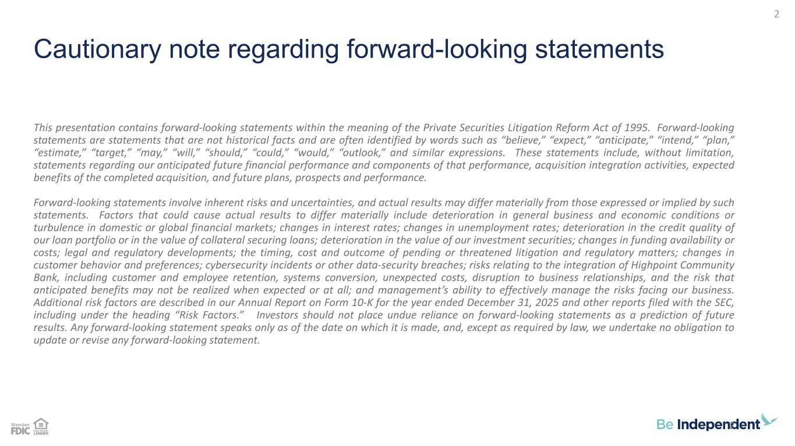
Cautionary note regarding forward-looking statements This presentation contains forward-looking statements within the meaning of the Private Securities Litigation Reform Act of 1995. Forward-looking statements are statements that are not historical facts and are often identified by words such as “believe,” “expect,” “anticipate,” “intend,” “plan,” “estimate,” “target,” “may,” “will,” “should,” “could,” “would,” “outlook,” and similar expressions. These statements include, without limitation, statements regarding our anticipated future financial performance and components of that performance, acquisition integration activities, expected benefits of the completed acquisition, and future plans, prospects and performance. Forward-looking statements involve inherent risks and uncertainties, and actual results may differ materially from those expressed or implied by such statements. Factors that could cause actual results to differ materially include deterioration in general business and economic conditions or turbulence in domestic or global financial markets; changes in interest rates; changes in unemployment rates; deterioration in the credit quality of our loan portfolio or in the value of collateral securing loans; deterioration in the value of our investment securities; changes in funding availability or costs; legal and regulatory developments; the timing, cost and outcome of pending or threatened litigation and regulatory matters; changes in customer behavior and preferences; cybersecurity incidents or other data-security breaches; risks relating to the integration of Highpoint Community Bank, including customer and employee retention, systems conversion, unexpected costs, disruption to business relationships, and the risk that anticipated benefits may not be realized when expected or at all; and management’s ability to effectively manage the risks facing our business. Additional risk factors are described in our Annual Report on Form 10-K for the year ended December 31, 2025 and other reports filed with the SEC, including under the heading “Risk Factors.” Investors should not place undue reliance on forward-looking statements as a prediction of future results. Any forward-looking statement speaks only as of the date on which it is made, and, except as required by law, we undertake no obligation to update or revise any forward-looking statement. 2 2

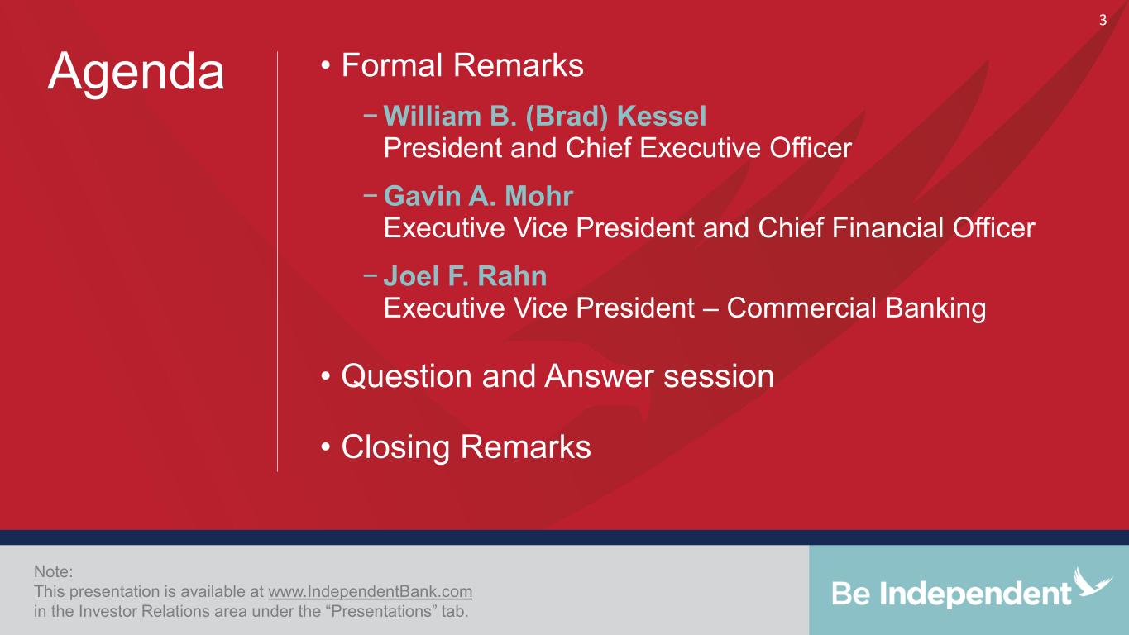
• Formal Remarks − William B. (Brad) Kessel President and Chief Executive Officer − Gavin A. Mohr Executive Vice President and Chief Financial Officer − Joel F. Rahn Executive Vice President – Commercial Banking • Question and Answer session • Closing Remarks Note: This presentation is available at www.IndependentBank.com in the Investor Relations area under the “Presentations” tab. Agenda 3

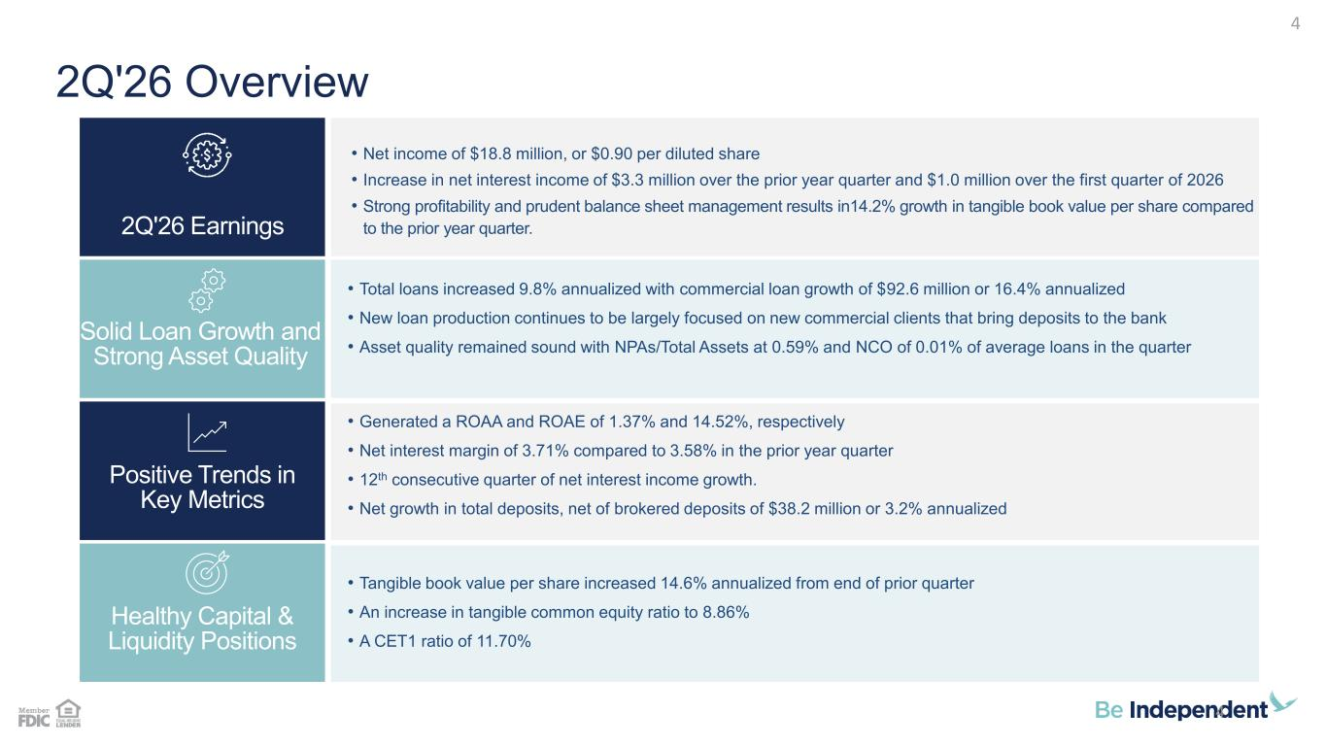
2Q'26 Overview • Total loans increased 9.8% annualized with commercial loan growth of $92.6 million or 16.4% annualized • New loan production continues to be largely focused on new commercial clients that bring deposits to the bank • Asset quality remained sound with NPAs/Total Assets at 0.59% and NCO of 0.01% of average loans in the quarter • Generated a ROAA and ROAE of 1.37% and 14.52%, respectively • Net interest margin of 3.71% compared to 3.58% in the prior year quarter • 12th consecutive quarter of net interest income growth. • Net growth in total deposits, net of brokered deposits of $38.2 million or 3.2% annualized • Tangible book value per share increased 14.6% annualized from end of prior quarter • An increase in tangible common equity ratio to 8.86% • A CET1 ratio of 11.70% • Net income of $18.8 million, or $0.90 per diluted share • Increase in net interest income of $3.3 million over the prior year quarter and $1.0 million over the first quarter of 2026 • Strong profitability and prudent balance sheet management results in14.2% growth in tangible book value per share compared to the prior year quarter. Healthy Capital & Liquidity Positions Positive Trends in Key Metrics Solid Loan Growth and Strong Asset Quality 2Q'26 Earnings 4 4

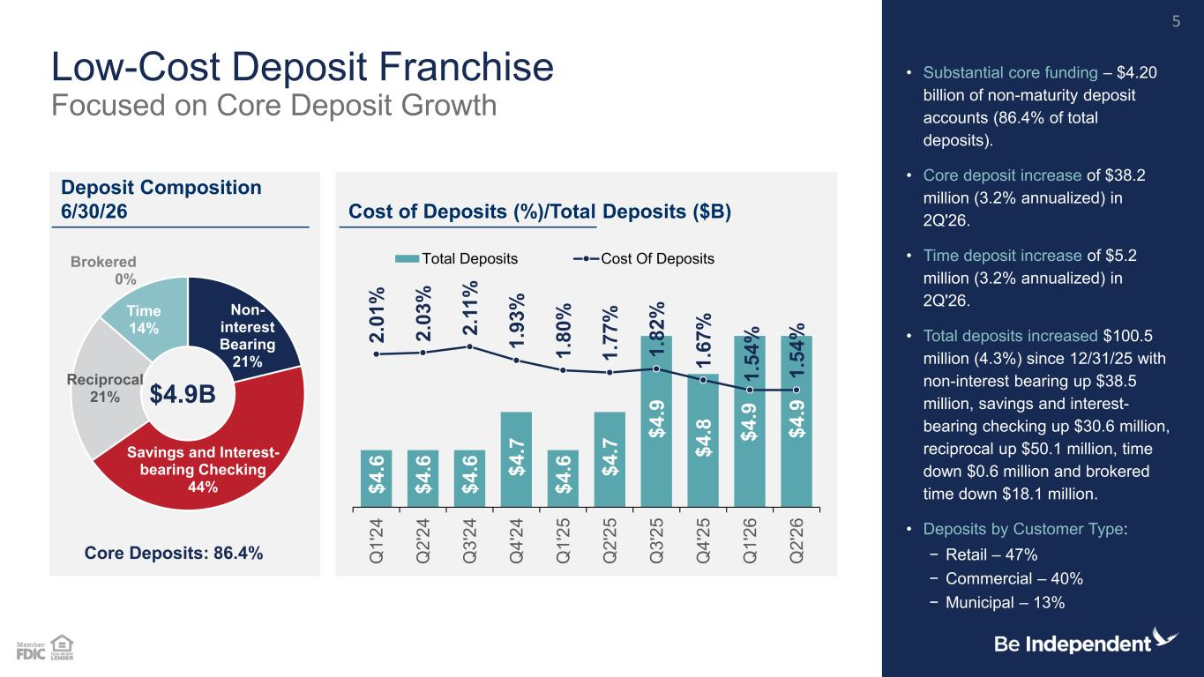
$ 4 .6 $ 4 .6 $ 4 .6 $ 4 .7 $ 4 .6 $ 4 .7 $ 4 .9 $ 4 .8 $ 4 .9 $ 4 .9 2 .0 1 % 2 .0 3 % 2 .1 1 % 1 .9 3 % 1 .8 0 % 1 .7 7 % 1 .8 2 % 1 .6 7 % 1 .5 4 % 1 .5 4 % Q 1 '2 4 Q 2 '2 4 Q 3 '2 4 Q 4 '2 4 Q 1 '2 5 Q 2 '2 5 Q 3 '2 5 Q 4 '2 5 Q 1 '2 6 Q 2 '2 6 Total Deposits Cost Of Deposits Low-Cost Deposit Franchise Focused on Core Deposit Growth • Substantial core funding – $4.20 billion of non-maturity deposit accounts (86.4% of total deposits). • Core deposit increase of $38.2 million (3.2% annualized) in 2Q'26. • Time deposit increase of $5.2 million (3.2% annualized) in 2Q'26. • Total deposits increased $100.5 million (4.3%) since 12/31/25 with non-interest bearing up $38.5 million, savings and interest- bearing checking up $30.6 million, reciprocal up $50.1 million, time down $0.6 million and brokered time down $18.1 million. • Deposits by Customer Type: − Retail – 47% − Commercial – 40% − Municipal – 13% Deposit Composition 6/30/26 Cost of Deposits (%)/Total Deposits ($B) 5 Core Deposits: 86.4% $4.9B Non- interest Bearing 21% Savings and Interest- bearing Checking 44% Reciprocal 21% Time 14% Brokered 0%

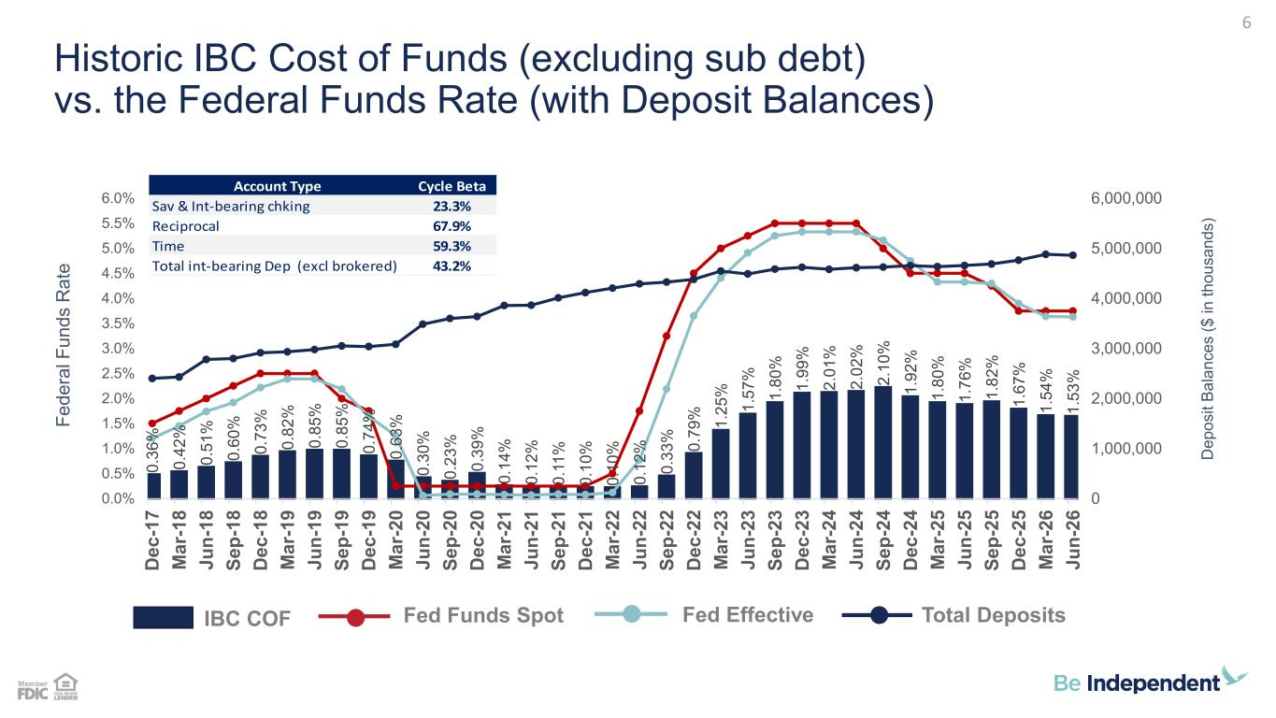
Historic IBC Cost of Funds (excluding sub debt) vs. the Federal Funds Rate (with Deposit Balances) D e p o s it B a la n c e s ( $ i n t h o u s a n d s ) 6 F e d e ra l F u n d s R a te Account Type Cycle Beta Sav & Int-bearing chking 23.3% Reciprocal 67.9% Time 59.3% Total int-bearing Dep (excl brokered) 43.2% IBC COF Fed Funds Spot Fed Effective Total Deposits 0 .3 6 % 0 .4 2 % 0 .5 1 % 0 .6 0 % 0 .7 3 % 0 .8 2 % 0 .8 5 % 0 .8 5 % 0 .7 4 % 0 .6 3 % 0 .3 0 % 0 .2 3 % 0 .3 9 % 0 .1 4 % 0 .1 2 % 0 .1 1 % 0 .1 0 % 0 .1 0 % 0 .1 2 % 0 .3 3 % 0 .7 9 % 1 .2 5 % 1 .5 7 % 1 .8 0 % 1 .9 9 % 2 .0 1 % 2 .0 2 % 2 .1 0 % 1 .9 2 % 1 .8 0 % 1 .7 6 % 1 .8 2 % 1 .6 7 % 1 .5 4 % 1 .5 3 % 0 1,000,000 2,000,000 3,000,000 4,000,000 5,000,000 6,000,000 0.0% 0.5% 1.0% 1.5% 2.0% 2.5% 3.0% 3.5% 4.0% 4.5% 5.0% 5.5% 6.0% D e c -1 7 M a r- 1 8 J u n -1 8 S e p -1 8 D e c -1 8 M a r- 1 9 J u n -1 9 S e p -1 9 D e c -1 9 M a r- 2 0 J u n -2 0 S e p -2 0 D e c -2 0 M a r- 2 1 J u n -2 1 S e p -2 1 D e c -2 1 M a r- 2 2 J u n -2 2 S e p -2 2 D e c -2 2 M a r- 2 3 J u n -2 3 S e p -2 3 D e c -2 3 M a r- 2 4 J u n -2 4 S e p -2 4 D e c -2 4 M a r- 2 5 J u n -2 5 S e p -2 5 D e c -2 5 M a r- 2 6 J u n -2 6

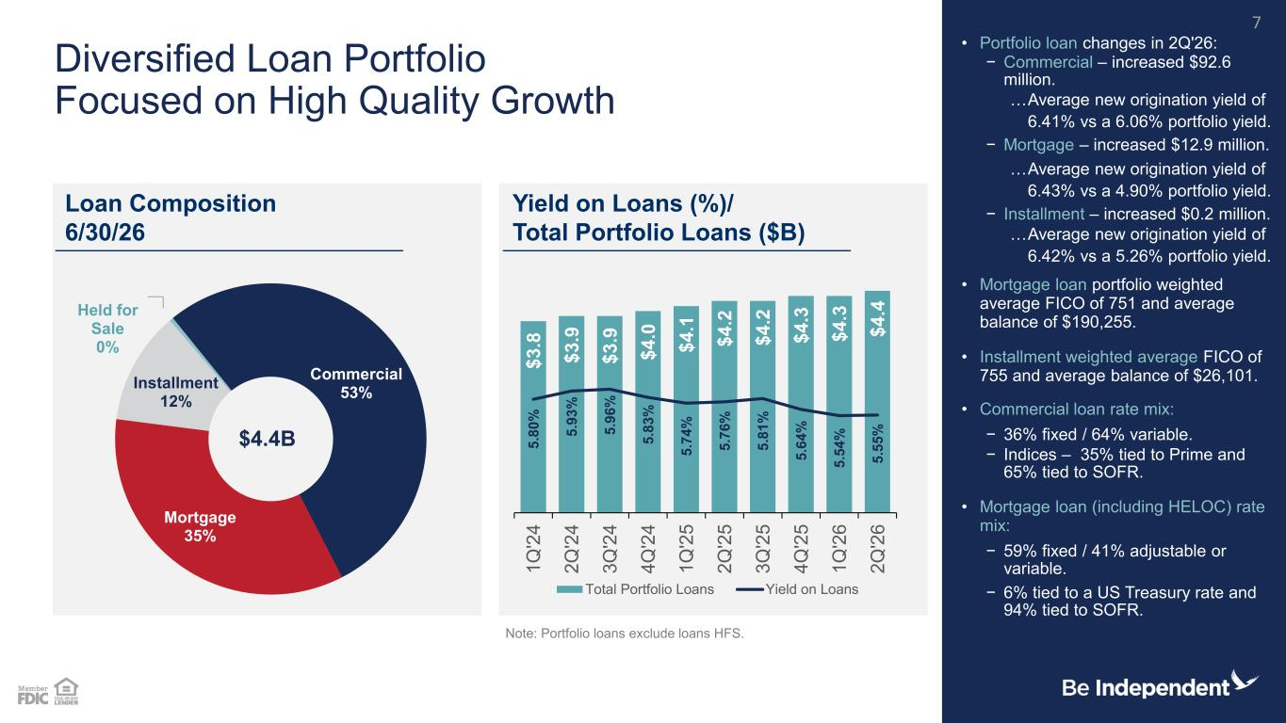
Commercial 53% Mortgage 35% Installment 12% Held for Sale 0% Diversified Loan Portfolio Focused on High Quality Growth • Portfolio loan changes in 2Q'26: − Commercial – increased $92.6 million. …Average new origination yield of 6.41% vs a 6.06% portfolio yield. − Mortgage – increased $12.9 million. …Average new origination yield of 6.43% vs a 4.90% portfolio yield. − Installment – increased $0.2 million. …Average new origination yield of 6.42% vs a 5.26% portfolio yield. • Mortgage loan portfolio weighted average FICO of 751 and average balance of $190,255. • Installment weighted average FICO of 755 and average balance of $26,101. • Commercial loan rate mix: − 36% fixed / 64% variable. − Indices – 35% tied to Prime and 65% tied to SOFR. • Mortgage loan (including HELOC) rate mix: − 59% fixed / 41% adjustable or variable. − 6% tied to a US Treasury rate and 94% tied to SOFR. Note: Portfolio loans exclude loans HFS. Loan Composition 6/30/26 Yield on Loans (%)/ Total Portfolio Loans ($B) 7 $4.4B $ 3 .8 $ 3 .9 $ 3 .9 $ 4 .0 $ 4 .1 $ 4 .2 $ 4 .2 $ 4 .3 $ 4 .3 $ 4 .4 5 .8 0 % 5 .9 3 % 5 .9 6 % 5 .8 3 % 5 .7 4 % 5 .7 6 % 5 .8 1 % 5 .6 4 % 5 .5 4 % 5 .5 5 % 1 Q '2 4 2 Q '2 4 3 Q '2 4 4 Q '2 4 1 Q '2 5 2 Q '2 5 3 Q '2 5 4 Q '2 5 1 Q '2 6 2 Q '2 6 Total Portfolio Loans Yield on Loans

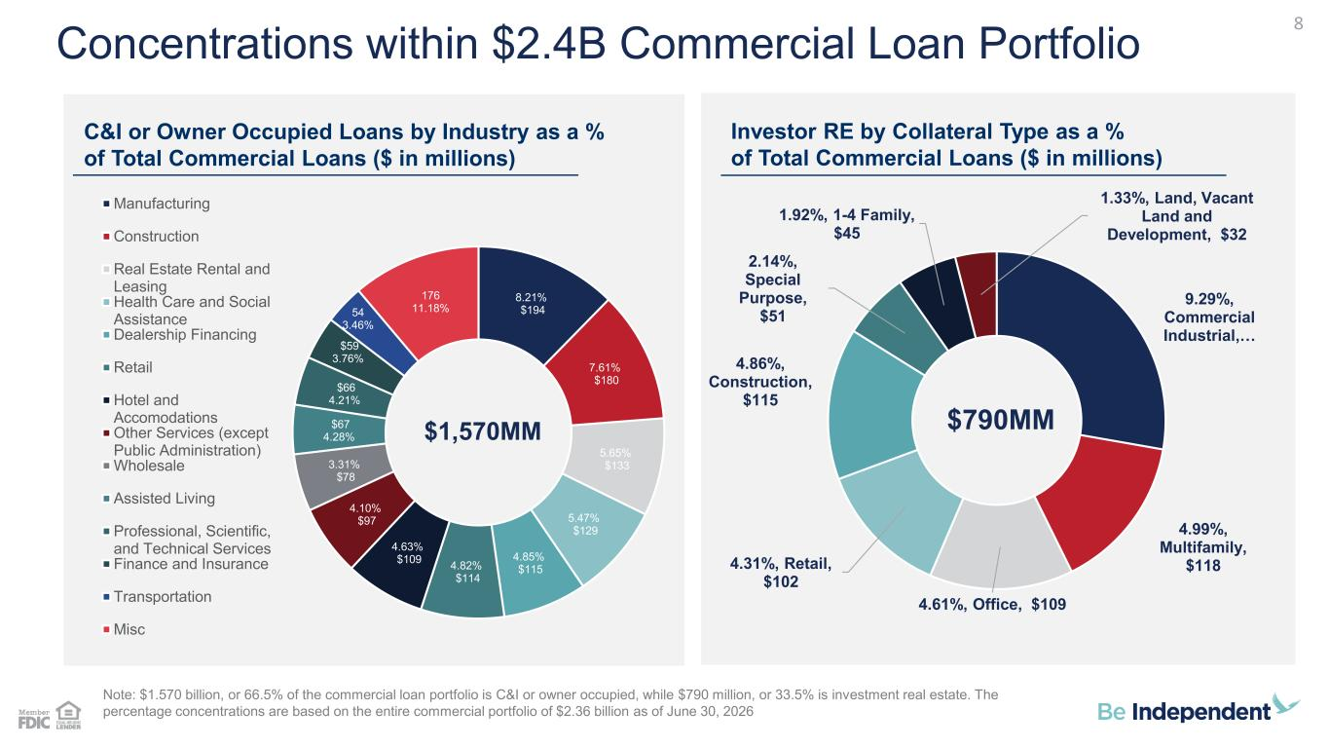
Concentrations within $2.4B Commercial Loan Portfolio C&I or Owner Occupied Loans by Industry as a % of Total Commercial Loans ($ in millions) Investor RE by Collateral Type as a % of Total Commercial Loans ($ in millions) Note: $1.570 billion, or 66.5% of the commercial loan portfolio is C&I or owner occupied, while $790 million, or 33.5% is investment real estate. The percentage concentrations are based on the entire commercial portfolio of $2.36 billion as of June 30, 2026 8 8.21% $194 7.61% $180 5.65% $133 5.47% $129 4.85% $115 4.82% $114 4.63% $109 4.10% $97 3.31% $78 $67 4.28% $66 4.21% $59 3.76% 54 3.46% 176 11.18% $1,570MM Manufacturing Construction Real Estate Rental and Leasing Health Care and Social Assistance Dealership Financing Retail Hotel and Accomodations Other Services (except Public Administration) Wholesale Assisted Living Professional, Scientific, and Technical Services Finance and Insurance Transportation Misc 9.29%, Commercial Industrial, … 4.99%, Multifamily, $118 4.61%, Office, $109 4.31%, Retail, $102 4.86%, Construction, $115 2.14%, Special Purpose, $51 1.92%, 1-4 Family, $45 1.33%, Land, Vacant Land and Development, $32 $790MM

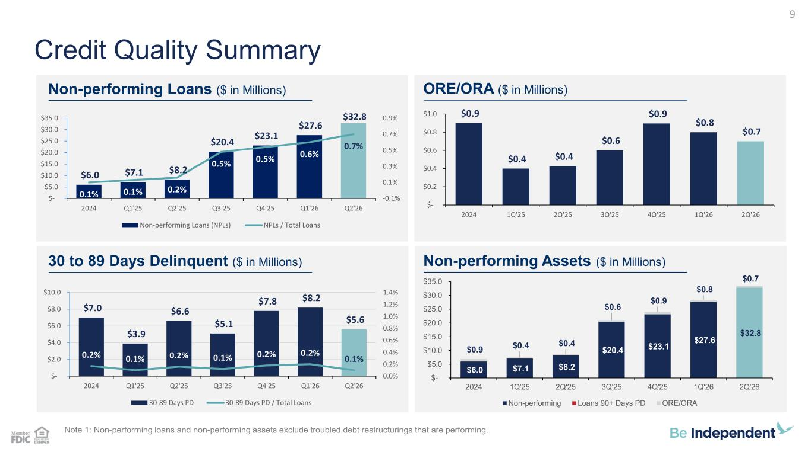
$6.0 $7.1 $8.2 $20.4 $23.1 $27.6 $32.8 $0.9 $0.4 $0.4 $0.6 $0.9 $0.8 $0.7 $- $5.0 $10.0 $15.0 $20.0 $25.0 $30.0 $35.0 2024 1Q'25 2Q'25 3Q'25 4Q'25 1Q'26 2Q'26 Non-performing Loans 90+ Days PD ORE/ORA $7.0 $3.9 $6.6 $5.1 $7.8 $8.2 $5.6 0.2% 0.1% 0.2% 0.1% 0.2% 0.2% 0.1% 0.0% 0.2% 0.4% 0.6% 0.8% 1.0% 1.2% 1.4% $- $2.0 $4.0 $6.0 $8.0 $10.0 2024 Q1'25 Q2'25 Q3'25 Q4'25 Q1'26 Q2'26 30-89 Days PD 30-89 Days PD / Total Loans $0.9 $0.4 $0.4 $0.6 $0.9 $0.8 $0.7 $- $0.2 $0.4 $0.6 $0.8 $1.0 2024 1Q'25 2Q'25 3Q'25 4Q'25 1Q'26 2Q'26 $6.0 $7.1 $8.2 $20.4 $23.1 $27.6 $32.8 0.1% 0.1% 0.2% 0.5% 0.5% 0.6% 0.7% -0.1% 0.1% 0.3% 0.5% 0.7% 0.9% $- $5.0 $10.0 $15.0 $20.0 $25.0 $30.0 $35.0 2024 Q1'25 Q2'25 Q3'25 Q4'25 Q1'26 Q2'26 Non-performing Loans (NPLs) NPLs / Total Loans Note 1: Non-performing loans and non-performing assets exclude troubled debt restructurings that are performing. Credit Quality Summary Non-performing Loans ($ in Millions) ORE/ORA ($ in Millions) 30 to 89 Days Delinquent ($ in Millions) Non-performing Assets ($ in Millions) 9

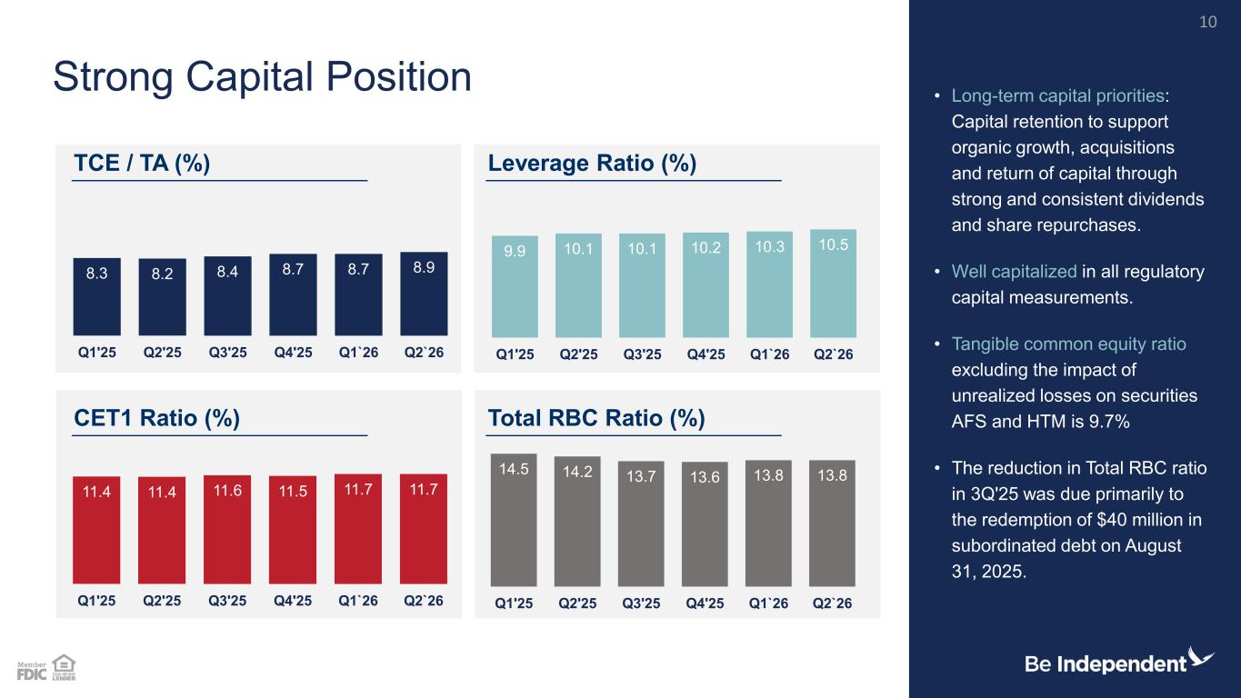
14.5 14.2 13.7 13.6 13.8 13.8 Q1'25 Q2'25 Q3'25 Q4'25 Q1`26 Q2`26 11.4 11.4 11.6 11.5 11.7 11.7 Q1'25 Q2'25 Q3'25 Q4'25 Q1`26 Q2`26 9.9 10.1 10.1 10.2 10.3 10.5 Q1'25 Q2'25 Q3'25 Q4'25 Q1`26 Q2`26 8.3 8.2 8.4 8.7 8.7 8.9 Q1'25 Q2'25 Q3'25 Q4'25 Q1`26 Q2`26 • Long-term capital priorities: Capital retention to support organic growth, acquisitions and return of capital through strong and consistent dividends and share repurchases. • Well capitalized in all regulatory capital measurements. • Tangible common equity ratio excluding the impact of unrealized losses on securities AFS and HTM is 9.7% • The reduction in Total RBC ratio in 3Q'25 was due primarily to the redemption of $40 million in subordinated debt on August 31, 2025. Strong Capital Position TCE / TA (%) Leverage Ratio (%) CET1 Ratio (%) Total RBC Ratio (%) 10

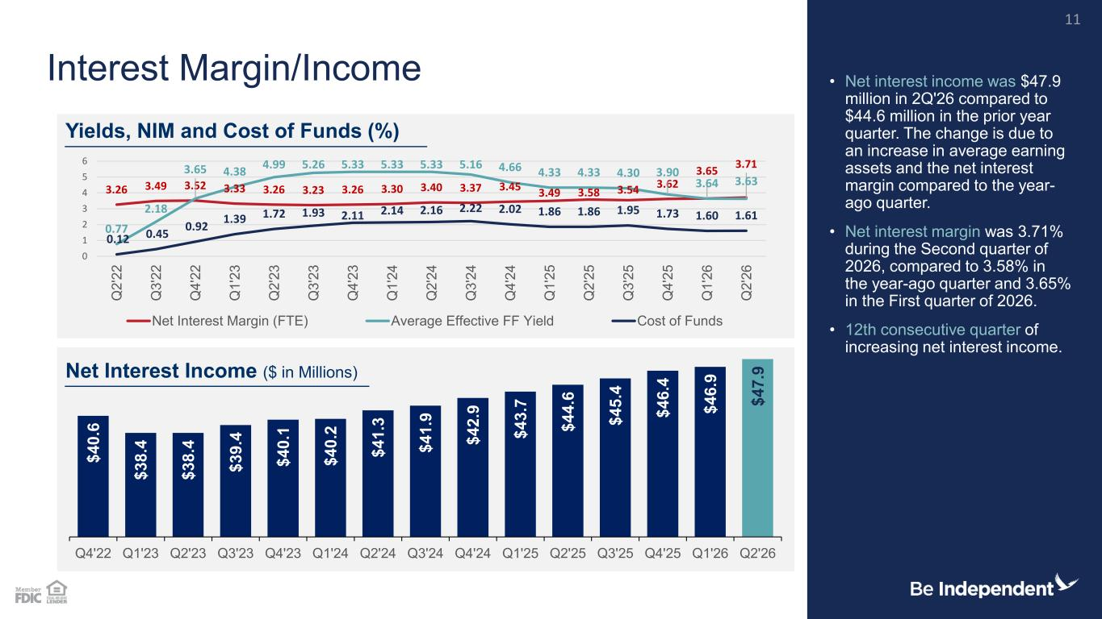
$ 4 0 .6 $ 3 8 .4 $ 3 8 .4 $ 3 9 .4 $ 4 0 .1 $ 4 0 .2 $ 4 1 .3 $ 4 1 .9 $ 4 2 .9 $ 4 3 .7 $ 4 4 .6 $ 4 5 .4 $ 4 6 .4 $ 4 6 .9 $ 4 7 .9 Q4'22 Q1'23 Q2'23 Q3'23 Q4'23 Q1'24 Q2'24 Q3'24 Q4'24 Q1'25 Q2'25 Q3'25 Q4'25 Q1'26 Q2'26 3.26 3.49 3.52 3.33 3.26 3.23 3.26 3.30 3.40 3.37 3.45 3.49 3.58 3.54 3.62 3.65 3.71 0.77 2.18 3.65 4.38 4.99 5.26 5.33 5.33 5.33 5.16 4.66 4.33 4.33 4.30 3.90 3.64 3.63 0.12 0.45 0.92 1.39 1.72 1.93 2.11 2.14 2.16 2.22 2.02 1.86 1.86 1.95 1.73 1.60 1.61 0 1 2 3 4 5 6 Q 2 '2 2 Q 3 '2 2 Q 4 '2 2 Q 1 '2 3 Q 2 '2 3 Q 3 '2 3 Q 4 '2 3 Q 1 '2 4 Q 2 '2 4 Q 3 '2 4 Q 4 '2 4 Q 1 '2 5 Q 2 '2 5 Q 3 '2 5 Q 4 '2 5 Q 1 '2 6 Q 2 '2 6 Net Interest Margin (FTE) Average Effective FF Yield Cost of Funds Net Interest Margin/Income • Net interest income was $47.9 million in 2Q'26 compared to $44.6 million in the prior year quarter. The change is due to an increase in average earning assets and the net interest margin compared to the year- ago quarter. • Net interest margin was 3.71% during the Second quarter of 2026, compared to 3.58% in the year-ago quarter and 3.65% in the First quarter of 2026. • 12th consecutive quarter of increasing net interest income. Yields, NIM and Cost of Funds (%) Net Interest Income ($ in Millions) 11

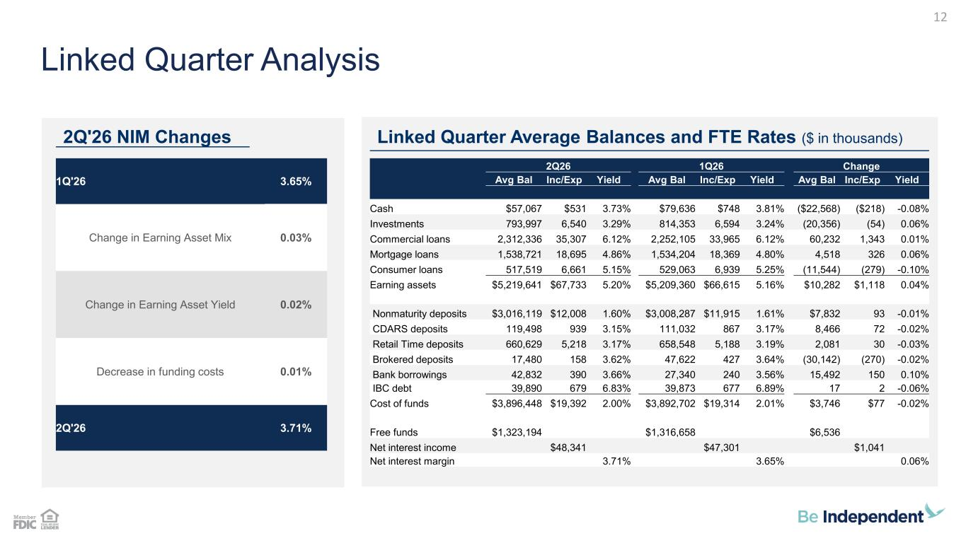
2Q26 1Q26 Change Avg Bal Inc/Exp Yield Avg Bal Inc/Exp Yield Avg Bal Inc/Exp Yield Cash $57,067 $531 3.73% $79,636 $748 3.81% ($22,568) ($218) -0.08% Investments 793,997 6,540 3.29% 814,353 6,594 3.24% (20,356) (54) 0.06% Commercial loans 2,312,336 35,307 6.12% 2,252,105 33,965 6.12% 60,232 1,343 0.01% Mortgage loans 1,538,721 18,695 4.86% 1,534,204 18,369 4.80% 4,518 326 0.06% Consumer loans 517,519 6,661 5.15% 529,063 6,939 5.25% (11,544) (279) -0.10% Earning assets $5,219,641 $67,733 5.20% $5,209,360 $66,615 5.16% $10,282 $1,118 0.04% Nonmaturity deposits $3,016,119 $12,008 1.60% $3,008,287 $11,915 1.61% $7,832 93 -0.01% CDARS deposits 119,498 939 3.15% 111,032 867 3.17% 8,466 72 -0.02% Retail Time deposits 660,629 5,218 3.17% 658,548 5,188 3.19% 2,081 30 -0.03% Brokered deposits 17,480 158 3.62% 47,622 427 3.64% (30,142) (270) -0.02% Bank borrowings 42,832 390 3.66% 27,340 240 3.56% 15,492 150 0.10% IBC debt 39,890 679 6.83% 39,873 677 6.89% 17 2 -0.06% Cost of funds $3,896,448 $19,392 2.00% $3,892,702 $19,314 2.01% $3,746 $77 -0.02% Free funds $1,323,194 $1,316,658 $6,536 Net interest income $48,341 $47,301 $1,041 Net interest margin 3.71% 3.65% 0.06% 2Q'26 NIM Changes Linked Quarter Average Balances and FTE Rates ($ in thousands) Linked Quarter Analysis 12 1Q'26 3.65% Change in Earning Asset Mix 0.03% Change in Earning Asset Yield 0.02% Decrease in funding costs 0.01% 2Q'26 3.71%

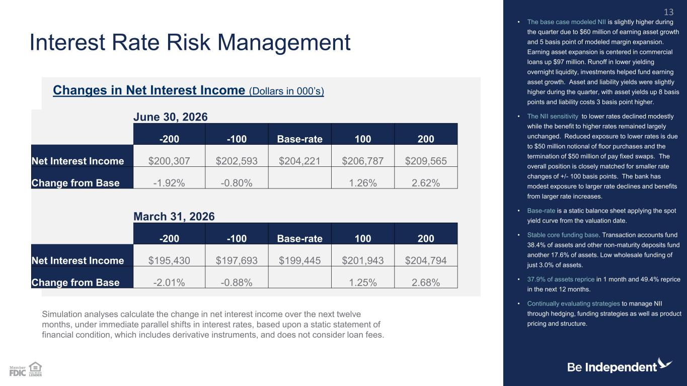
June 30, 2026 -200 -100 Base-rate 100 200 Net Interest Income $200,307 $202,593 $204,221 $206,787 $209,565 Change from Base -1.92% -0.80% 1.26% 2.62% March 31, 2026 -200 -100 Base-rate 100 200 Net Interest Income $195,430 $197,693 $199,445 $201,943 $204,794 Change from Base -2.01% -0.88% 1.25% 2.68% Interest Rate Risk Management • The base case modeled NII is slightly higher during the quarter due to $60 million of earning asset growth and 5 basis point of modeled margin expansion. Earning asset expansion is centered in commercial loans up $97 million. Runoff in lower yielding overnight liquidity, investments helped fund earning asset growth. Asset and liability yields were slightly higher during the quarter, with asset yields up 8 basis points and liability costs 3 basis point higher. • The NII sensitivity to lower rates declined modestly while the benefit to higher rates remained largely unchanged. Reduced exposure to lower rates is due to $50 million notional of floor purchases and the termination of $50 million of pay fixed swaps. The overall position is closely matched for smaller rate changes of +/- 100 basis points. The bank has modest exposure to larger rate declines and benefits from larger rate increases. • Base-rate is a static balance sheet applying the spot yield curve from the valuation date. • Stable core funding base. Transaction accounts fund 38.4% of assets and other non-maturity deposits fund another 17.6% of assets. Low wholesale funding of just 3.0% of assets. • 37.9% of assets reprice in 1 month and 49.4% reprice in the next 12 months. • Continually evaluating strategies to manage NII through hedging, funding strategies as well as product pricing and structure. Changes in Net Interest Income (Dollars in 000’s) Simulation analyses calculate the change in net interest income over the next twelve months, under immediate parallel shifts in interest rates, based upon a static statement of financial condition, which includes derivative instruments, and does not consider loan fees. 13

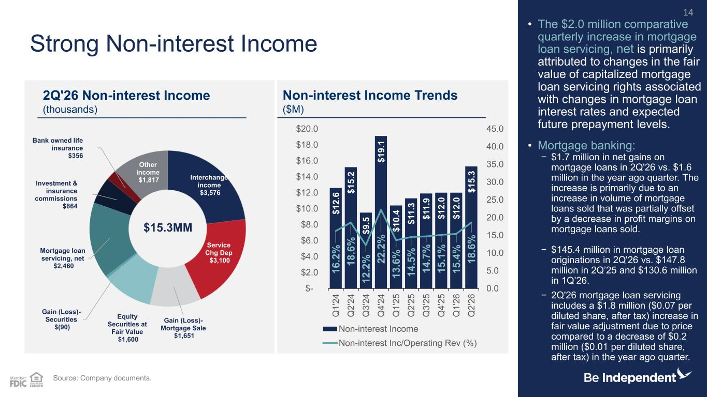
Interchange income $3,576 Service Chg Dep $3,100 Gain (Loss)- Mortgage Sale $1,651 Equity Securities at Fair Value $1,600 Gain (Loss)- Securities $(90) Mortgage loan servicing, net $2,460 Investment & insurance commissions $864 Bank owned life insurance $356 Other income $1,817 Strong Non-interest Income • The $2.0 million comparative quarterly increase in mortgage loan servicing, net is primarily attributed to changes in the fair value of capitalized mortgage loan servicing rights associated with changes in mortgage loan interest rates and expected future prepayment levels. • Mortgage banking: − $1.7 million in net gains on mortgage loans in 2Q'26 vs. $1.6 million in the year ago quarter. The increase is primarily due to an increase in volume of mortgage loans sold that was partially offset by a decrease in profit margins on mortgage loans sold. − $145.4 million in mortgage loan originations in 2Q'26 vs. $147.8 million in 2Q’25 and $130.6 million in 1Q’26. − 2Q'26 mortgage loan servicing includes a $1.8 million ($0.07 per diluted share, after tax) increase in fair value adjustment due to price compared to a decrease of $0.2 million ($0.01 per diluted share, after tax) in the year ago quarter. Source: Company documents. 2Q'26 Non-interest Income (thousands) Non-interest Income Trends ($M) 14 $15.3MM $ 1 2 .6 $ 1 5 .2 $ 9 .5 $ 1 9 .1 $ 1 0 .4 $ 1 1 .3 $ 1 1 .9 $ 1 2 .0 $ 1 2 .0 $ 1 5 .3 1 6 .2 % 1 8 .6 % 1 2 .2 % 2 2 .2 % 1 3 .6 % 1 4 .5 % 1 4 .7 % 1 5 .1 % 1 5 .4 % 1 8 .6 % 0.0 5.0 10.0 15.0 20.0 25.0 30.0 35.0 40.0 45.0 $- $2.0 $4.0 $6.0 $8.0 $10.0 $12.0 $14.0 $16.0 $18.0 $20.0 Q 1 '2 4 Q 2 '2 4 Q 3 '2 4 Q 4 '2 4 Q 1 '2 5 Q 2 '2 5 Q 3 '2 5 Q 4 '2 5 Q 1 '2 6 Q 2 '2 6 Non-interest Income Non-interest Inc/Operating Rev (%)

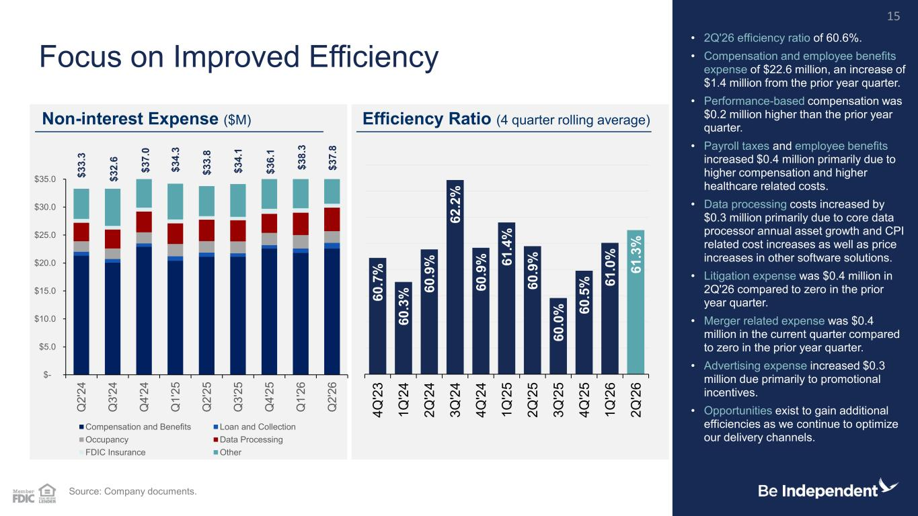
6 0 .7 % 6 0 .3 % 6 0 .9 % 6 2 .2 % 6 0 .9 % 6 1 .4 % 6 0 .9 % 6 0 .0 % 6 0 .5 % 6 1 .0 % 6 1 .3 % 4 Q '2 3 1 Q '2 4 2 Q '2 4 3 Q '2 4 4 Q '2 4 1 Q '2 5 2 Q '2 5 3 Q '2 5 4 Q '2 5 1 Q '2 6 2 Q '2 6 $ 3 3 .3 $ 3 2 .6 $ 3 4 .3 $ 3 3 .8 $ 3 4 .1 $- $5.0 $10.0 $15.0 $20.0 $25.0 $30.0 $35.0 Q 2 '2 4 Q 3 '2 4 Q 4 '2 4 Q 1 '2 5 Q 2 '2 5 Q 3 '2 5 Q 4 '2 5 Q 1 '2 6 Q 2 '2 6 Compensation and Benefits Loan and Collection Occupancy Data Processing FDIC Insurance Other Focus on Improved Efficiency • 2Q'26 efficiency ratio of 60.6%. • Compensation and employee benefits expense of $22.6 million, an increase of $1.4 million from the prior year quarter. • Performance-based compensation was $0.2 million higher than the prior year quarter. • Payroll taxes and employee benefits increased $0.4 million primarily due to higher compensation and higher healthcare related costs. • Data processing costs increased by $0.3 million primarily due to core data processor annual asset growth and CPI related cost increases as well as price increases in other software solutions. • Litigation expense was $0.4 million in 2Q'26 compared to zero in the prior year quarter. • Merger related expense was $0.4 million in the current quarter compared to zero in the prior year quarter. • Advertising expense increased $0.3 million due primarily to promotional incentives. • Opportunities exist to gain additional efficiencies as we continue to optimize our delivery channels. Non-interest Expense ($M) Efficiency Ratio (4 quarter rolling average) Source: Company documents. 15 $ 3 7 .0 $ 3 6 .1 $ 3 8 .3 $ 3 7 .8

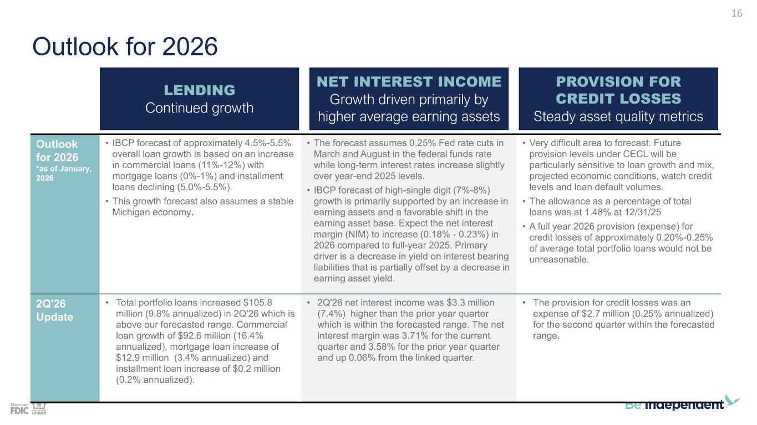
Outlook for 2026 Outlook for 2026 *as of January, 2026 • IBCP forecast of approximately 4.5%-5.5% overall loan growth is based on an increase in commercial loans (11%-12%) with mortgage loans (0%-1%) and installment loans declining (5.0%-5.5%). • This growth forecast also assumes a stable Michigan economy. • The forecast assumes 0.25% Fed rate cuts in March and August in the federal funds rate while long-term interest rates increase slightly over year-end 2025 levels. • IBCP forecast of high-single digit (7%-8%) growth is primarily supported by an increase in earning assets and a favorable shift in the earning asset base. Expect the net interest margin (NIM) to increase (0.18% - 0.23%) in 2026 compared to full-year 2025. Primary driver is a decrease in yield on interest bearing liabilities that is partially offset by a decrease in earning asset yield. • Very difficult area to forecast. Future provision levels under CECL will be particularly sensitive to loan growth and mix, projected economic conditions, watch credit levels and loan default volumes. • The allowance as a percentage of total loans was at 1.48% at 12/31/25 • A full year 2026 provision (expense) for credit losses of approximately 0.20%-0.25% of average total portfolio loans would not be unreasonable. 2Q'26 Update • Total portfolio loans increased $105.8 million (9.8% annualized) in 2Q'26 which is above our forecasted range. Commercial loan growth of $92.6 million (16.4% annualized), mortgage loan increase of $12.9 million (3.4% annualized) and installment loan increase of $0.2 million (0.2% annualized). • 2Q'26 net interest income was $3.3 million (7.4%) higher than the prior year quarter which is within the forecasted range. The net interest margin was 3.71% for the current quarter and 3.58% for the prior year quarter and up 0.06% from the linked quarter. • The provision for credit losses was an expense of $2.7 million (0.25% annualized) for the second quarter within the forecasted range. LENDING Continued growth NET INTEREST INCOME Growth driven primarily by higher average earning assets PROVISION FOR CREDIT LOSSES Steady asset quality metrics 16

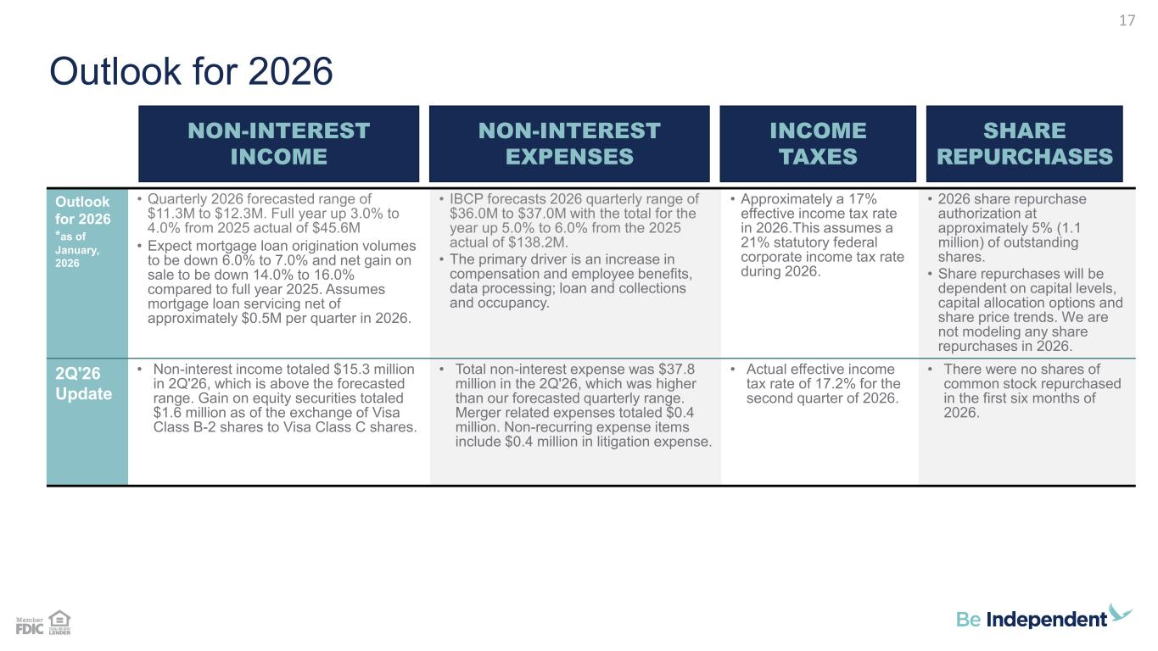
Outlook for 2026 Outlook for 2026 *as of January, 2026 • Quarterly 2026 forecasted range of $11.3M to $12.3M. Full year up 3.0% to 4.0% from 2025 actual of $45.6M • Expect mortgage loan origination volumes to be down 6.0% to 7.0% and net gain on sale to be down 14.0% to 16.0% compared to full year 2025. Assumes mortgage loan servicing net of approximately $0.5M per quarter in 2026. • IBCP forecasts 2026 quarterly range of $36.0M to $37.0M with the total for the year up 5.0% to 6.0% from the 2025 actual of $138.2M. • The primary driver is an increase in compensation and employee benefits, data processing; loan and collections and occupancy. • Approximately a 17% effective income tax rate in 2026.This assumes a 21% statutory federal corporate income tax rate during 2026. • 2026 share repurchase authorization at approximately 5% (1.1 million) of outstanding shares. • Share repurchases will be dependent on capital levels, capital allocation options and share price trends. We are not modeling any share repurchases in 2026. 2Q'26 Update • Non-interest income totaled $15.3 million in 2Q'26, which is above the forecasted range. Gain on equity securities totaled $1.6 million as of the exchange of Visa Class B-2 shares to Visa Class C shares. • Total non-interest expense was $37.8 million in the 2Q'26, which was higher than our forecasted quarterly range. Merger related expenses totaled $0.4 million. Non-recurring expense items include $0.4 million in litigation expense. • Actual effective income tax rate of 17.2% for the second quarter of 2026. • There were no shares of common stock repurchased in the first six months of 2026. NON-INTEREST INCOME NON-INTEREST EXPENSES INCOME TAXES SHARE REPURCHASES 17

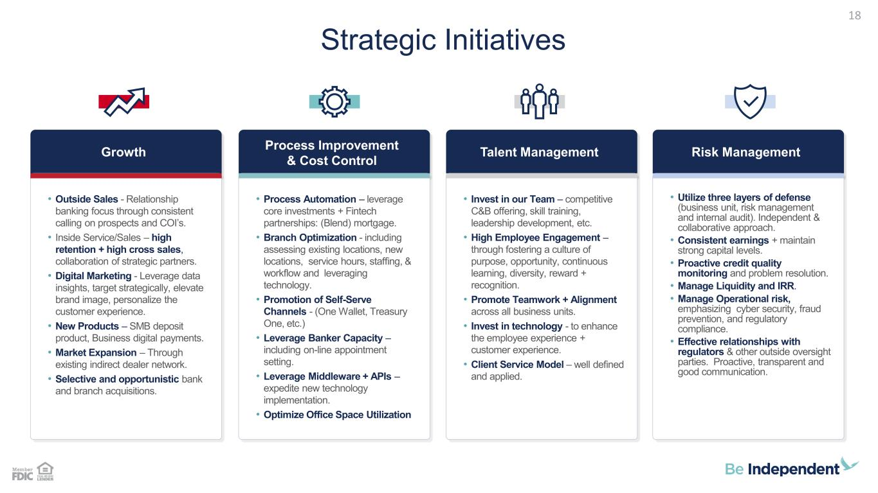
Strategic Initiatives 18 Growth • Outside Sales - Relationship banking focus through consistent calling on prospects and COI’s. • Inside Service/Sales – high retention + high cross sales, collaboration of strategic partners. • Digital Marketing - Leverage data insights, target strategically, elevate brand image, personalize the customer experience. • New Products – SMB deposit product, Business digital payments. • Market Expansion – Through existing indirect dealer network. • Selective and opportunistic bank and branch acquisitions. Process Improvement & Cost Control • Process Automation – leverage core investments + Fintech partnerships: (Blend) mortgage. • Branch Optimization - including assessing existing locations, new locations, service hours, staffing, & workflow and leveraging technology. • Promotion of Self-Serve Channels - (One Wallet, Treasury One, etc.) • Leverage Banker Capacity – including on-line appointment setting. • Leverage Middleware + APIs – expedite new technology implementation. • Optimize Office Space Utilization Talent Management • Invest in our Team – competitive C&B offering, skill training, leadership development, etc. • High Employee Engagement – through fostering a culture of purpose, opportunity, continuous learning, diversity, reward + recognition. • Promote Teamwork + Alignment across all business units. • Invest in technology - to enhance the employee experience + customer experience. • Client Service Model – well defined and applied. Risk Management • Utilize three layers of defense (business unit, risk management and internal audit). Independent & collaborative approach. • Consistent earnings + maintain strong capital levels. • Proactive credit quality monitoring and problem resolution. • Manage Liquidity and IRR. • Manage Operational risk, emphasizing cyber security, fraud prevention, and regulatory compliance. • Effective relationships with regulators & other outside oversight parties. Proactive, transparent and good communication.

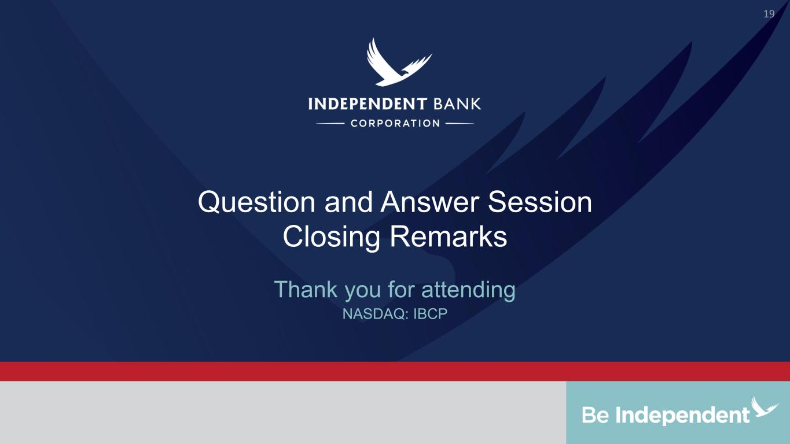
Question and Answer Session Closing Remarks NASDAQ: IBCP Thank you for attending 19

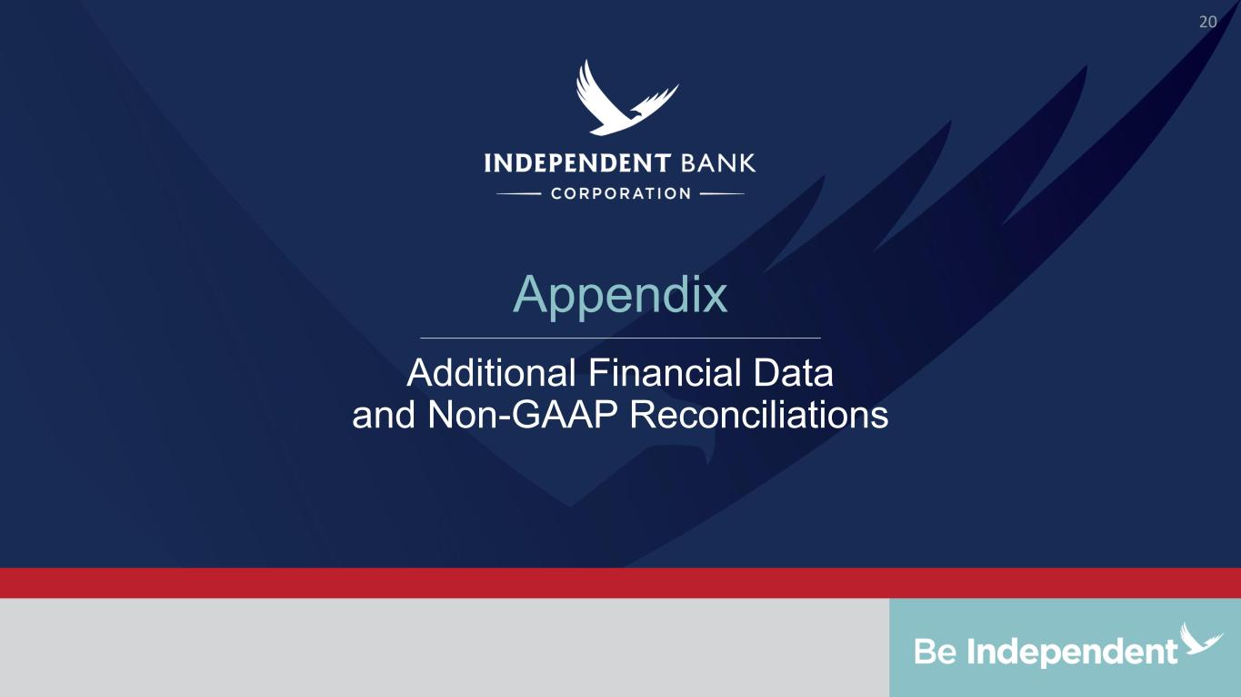
Appendix Additional Financial Data and Non-GAAP Reconciliations 20

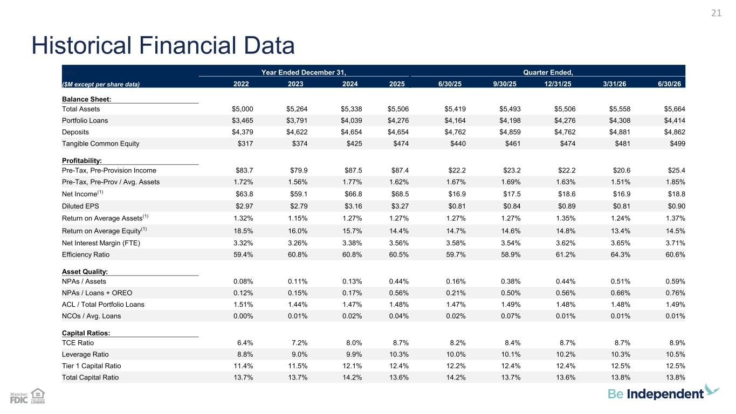
Historical Financial Data 21 here Year Ended December 31, Quarter Ended, ($M except per share data) 2022 2023 2024 2025 6/30/25 9/30/25 12/31/25 3/31/26 6/30/26 Balance Sheet: Total Assets $5,000 $5,264 $5,338 $5,506 $5,419 $5,493 $5,506 $5,558 $5,664 Portfolio Loans $3,465 $3,791 $4,039 $4,276 $4,164 $4,198 $4,276 $4,308 $4,414 Deposits $4,379 $4,622 $4,654 $4,654 $4,762 $4,859 $4,762 $4,881 $4,862 Tangible Common Equity $317 $374 $425 $474 $440 $461 $474 $481 $499 Profitability: Pre-Tax, Pre-Provision Income $83.7 $79.9 $87.5 $87.4 $22.2 $23.2 $22.2 $20.6 $25.4 Pre-Tax, Pre-Prov / Avg. Assets 1.72% 1.56% 1.77% 1.62% 1.67% 1.69% 1.63% 1.51% 1.85% Net Income(1) $63.8 $59.1 $66.8 $68.5 $16.9 $17.5 $18.6 $16.9 $18.8 Diluted EPS $2.97 $2.79 $3.16 $3.27 $0.81 $0.84 $0.89 $0.81 $0.90 Return on Average Assets(1) 1.32% 1.15% 1.27% 1.27% 1.27% 1.27% 1.35% 1.24% 1.37% Return on Average Equity(1) 18.5% 16.0% 15.7% 14.4% 14.7% 14.6% 14.8% 13.4% 14.5% Net Interest Margin (FTE) 3.32% 3.26% 3.38% 3.56% 3.58% 3.54% 3.62% 3.65% 3.71% Efficiency Ratio 59.4% 60.8% 60.8% 60.5% 59.7% 58.9% 61.2% 64.3% 60.6% Asset Quality: NPAs / Assets 0.08% 0.11% 0.13% 0.44% 0.16% 0.38% 0.44% 0.51% 0.59% NPAs / Loans + OREO 0.12% 0.15% 0.17% 0.56% 0.21% 0.50% 0.56% 0.66% 0.76% ACL / Total Portfolio Loans 1.51% 1.44% 1.47% 1.48% 1.47% 1.49% 1.48% 1.48% 1.49% NCOs / Avg. Loans 0.00% 0.01% 0.02% 0.04% 0.02% 0.07% 0.01% 0.01% 0.01% Capital Ratios: TCE Ratio 6.4% 7.2% 8.0% 8.7% 8.2% 8.4% 8.7% 8.7% 8.9% Leverage Ratio 8.8% 9.0% 9.9% 10.3% 10.0% 10.1% 10.2% 10.3% 10.5% Tier 1 Capital Ratio 11.4% 11.5% 12.1% 12.4% 12.2% 12.4% 12.4% 12.5% 12.5% Total Capital Ratio 13.7% 13.7% 14.2% 13.6% 14.2% 13.7% 13.6% 13.8% 13.8%

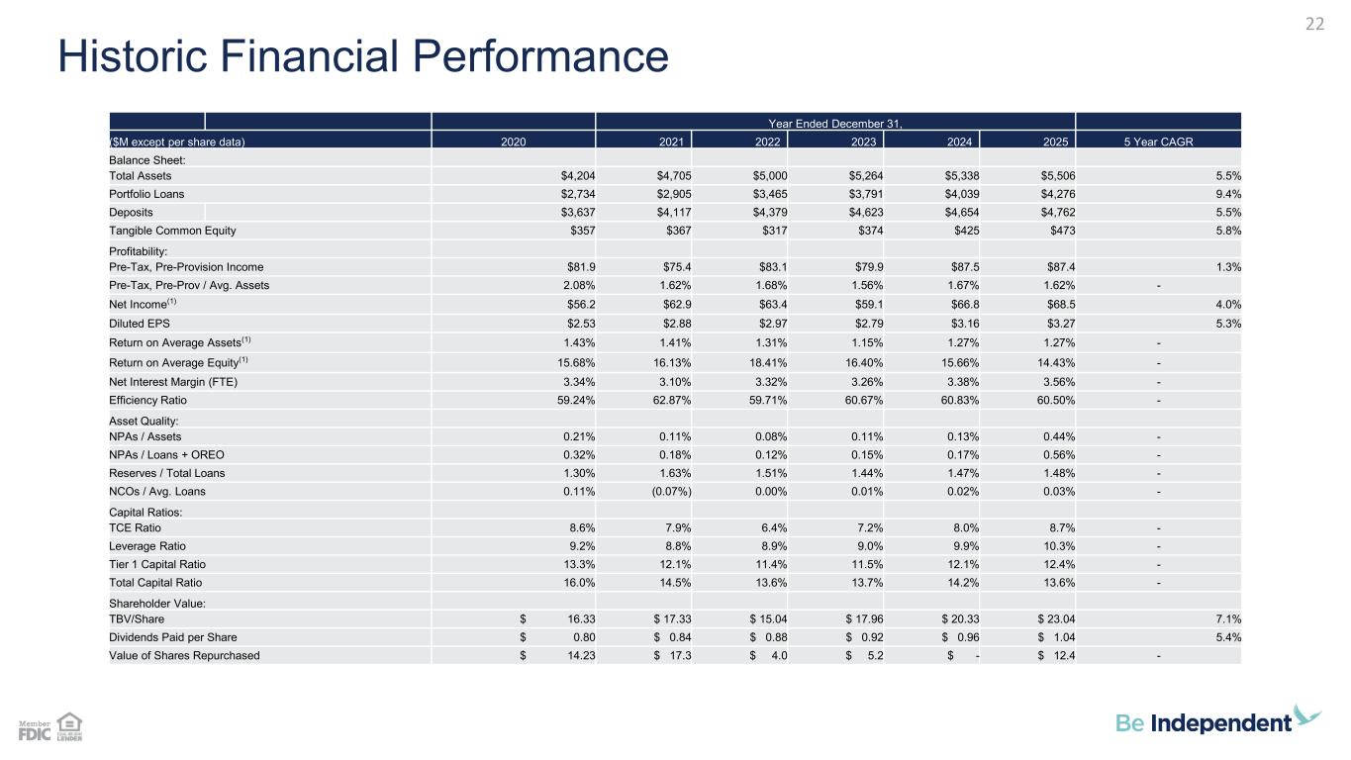
22 Historic Financial Performance Year Ended December 31, ($M except per share data) 2020 2021 2022 2023 2024 2025 5 Year CAGR Balance Sheet: Total Assets $4,204 $4,705 $5,000 $5,264 $5,338 $5,506 5.5% Portfolio Loans $2,734 $2,905 $3,465 $3,791 $4,039 $4,276 9.4% Deposits $3,637 $4,117 $4,379 $4,623 $4,654 $4,762 5.5% Tangible Common Equity $357 $367 $317 $374 $425 $473 5.8% Profitability: Pre-Tax, Pre-Provision Income $81.9 $75.4 $83.1 $79.9 $87.5 $87.4 1.3% Pre-Tax, Pre-Prov / Avg. Assets 2.08% 1.62% 1.68% 1.56% 1.67% 1.62% - Net Income(1) $56.2 $62.9 $63.4 $59.1 $66.8 $68.5 4.0% Diluted EPS $2.53 $2.88 $2.97 $2.79 $3.16 $3.27 5.3% Return on Average Assets(1) 1.43% 1.41% 1.31% 1.15% 1.27% 1.27% - Return on Average Equity(1) 15.68% 16.13% 18.41% 16.40% 15.66% 14.43% - Net Interest Margin (FTE) 3.34% 3.10% 3.32% 3.26% 3.38% 3.56% - Efficiency Ratio 59.24% 62.87% 59.71% 60.67% 60.83% 60.50% - Asset Quality: NPAs / Assets 0.21% 0.11% 0.08% 0.11% 0.13% 0.44% - NPAs / Loans + OREO 0.32% 0.18% 0.12% 0.15% 0.17% 0.56% - Reserves / Total Loans 1.30% 1.63% 1.51% 1.44% 1.47% 1.48% - NCOs / Avg. Loans 0.11% (0.07%) 0.00% 0.01% 0.02% 0.03% - Capital Ratios: TCE Ratio 8.6% 7.9% 6.4% 7.2% 8.0% 8.7% - Leverage Ratio 9.2% 8.8% 8.9% 9.0% 9.9% 10.3% - Tier 1 Capital Ratio 13.3% 12.1% 11.4% 11.5% 12.1% 12.4% - Total Capital Ratio 16.0% 14.5% 13.6% 13.7% 14.2% 13.6% - Shareholder Value: TBV/Share $ 16.33 $ 17.33 $ 15.04 $ 17.96 $ 20.33 $ 23.04 7.1% Dividends Paid per Share $ 0.80 $ 0.84 $ 0.88 $ 0.92 $ 0.96 $ 1.04 5.4% Value of Shares Repurchased $ 14.23 $ 17.3 $ 4.0 $ 5.2 $ - $ 12.4 -

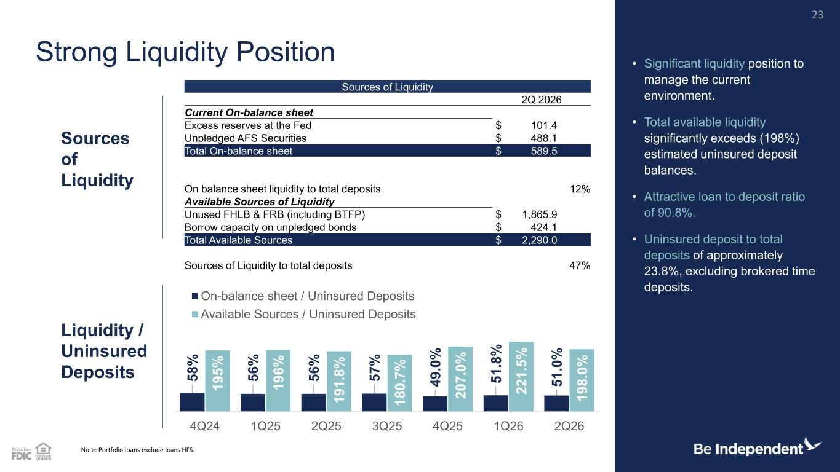
5 8 % 5 6 % 5 6 % 5 7 % 4 9 .0 % 5 1 .8 % 5 1 .0 % 1 9 5 % 1 9 6 % 1 9 1 .8 % 1 8 0 .7 % 2 0 7 .0 % 2 2 1 .5 % 1 9 8 .0 % 4Q24 1Q25 2Q25 3Q25 4Q25 1Q26 2Q26 On-balance sheet / Uninsured Deposits Available Sources / Uninsured Deposits Sources of Liquidity 2Q 2026 Current On-balance sheet Excess reserves at the Fed $ 101.4 Unpledged AFS Securities $ 488.1 Total On-balance sheet $ 589.5 On balance sheet liquidity to total deposits 12% Available Sources of Liquidity Unused FHLB & FRB (including BTFP) $ 1,865.9 Borrow capacity on unpledged bonds $ 424.1 Total Available Sources $ 2,290.0 Sources of Liquidity to total deposits 47% Note: Portfolio loans exclude loans HFS. Liquidity / Uninsured Deposits Strong Liquidity Position • Significant liquidity position to manage the current environment. • Total available liquidity significantly exceeds (198%) estimated uninsured deposit balances. • Attractive loan to deposit ratio of 90.8%. • Uninsured deposit to total deposits of approximately 23.8%, excluding brokered time deposits. Sources of Liquidity 23

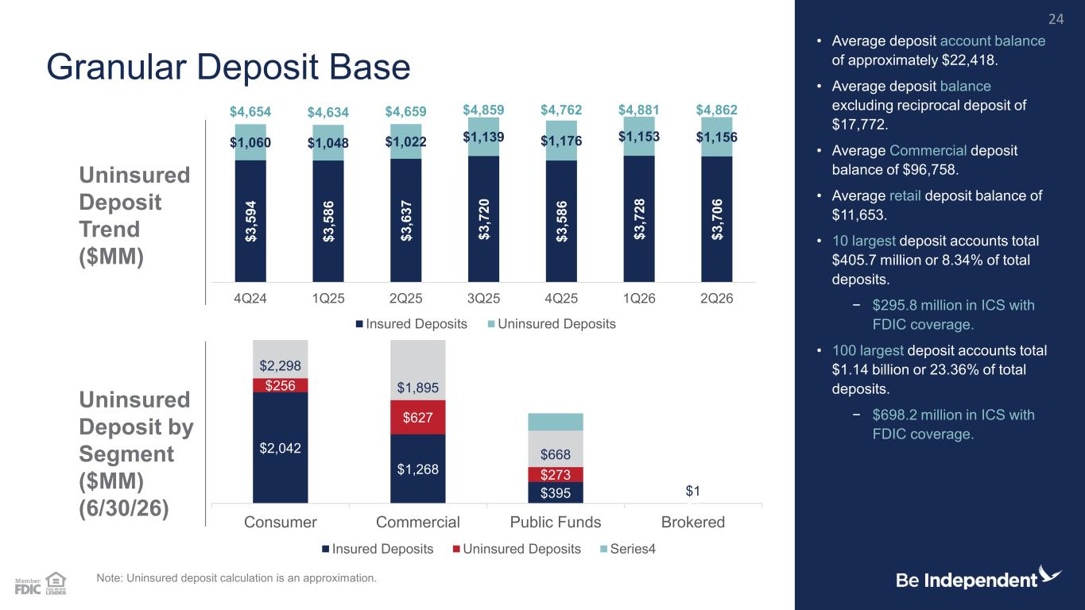
$ 3 ,5 9 4 $ 3 ,5 8 6 $ 3 ,6 3 7 $ 3 ,7 2 0 $ 3 ,5 8 6 $ 3 ,7 2 8 $ 3 ,7 0 6 $1,060 $1,048 $1,022 $1,139 $1,176 $1,153 $1,156 $4,654 $4,634 $4,659 $4,859 $4,762 $4,881 $4,862 4Q24 1Q25 2Q25 3Q25 4Q25 1Q26 2Q26 Insured Deposits Uninsured Deposits $2,042 $1,268 $395 $1 $256 $627 $273 $2,298 $1,895 $668 $1 Consumer Commercial Public Funds Brokered Insured Deposits Uninsured Deposits Series4 Granular Deposit Base • Average deposit account balance of approximately $22,418. • Average deposit balance excluding reciprocal deposit of $17,772. • Average Commercial deposit balance of $96,758. • Average retail deposit balance of $11,653. • 10 largest deposit accounts total $405.7 million or 8.34% of total deposits. − $295.8 million in ICS with FDIC coverage. • 100 largest deposit accounts total $1.14 billion or 23.36% of total deposits. − $698.2 million in ICS with FDIC coverage. Note: Uninsured deposit calculation is an approximation. Uninsured Deposit by Segment ($MM) (6/30/26) Uninsured Deposit Trend ($MM) 24

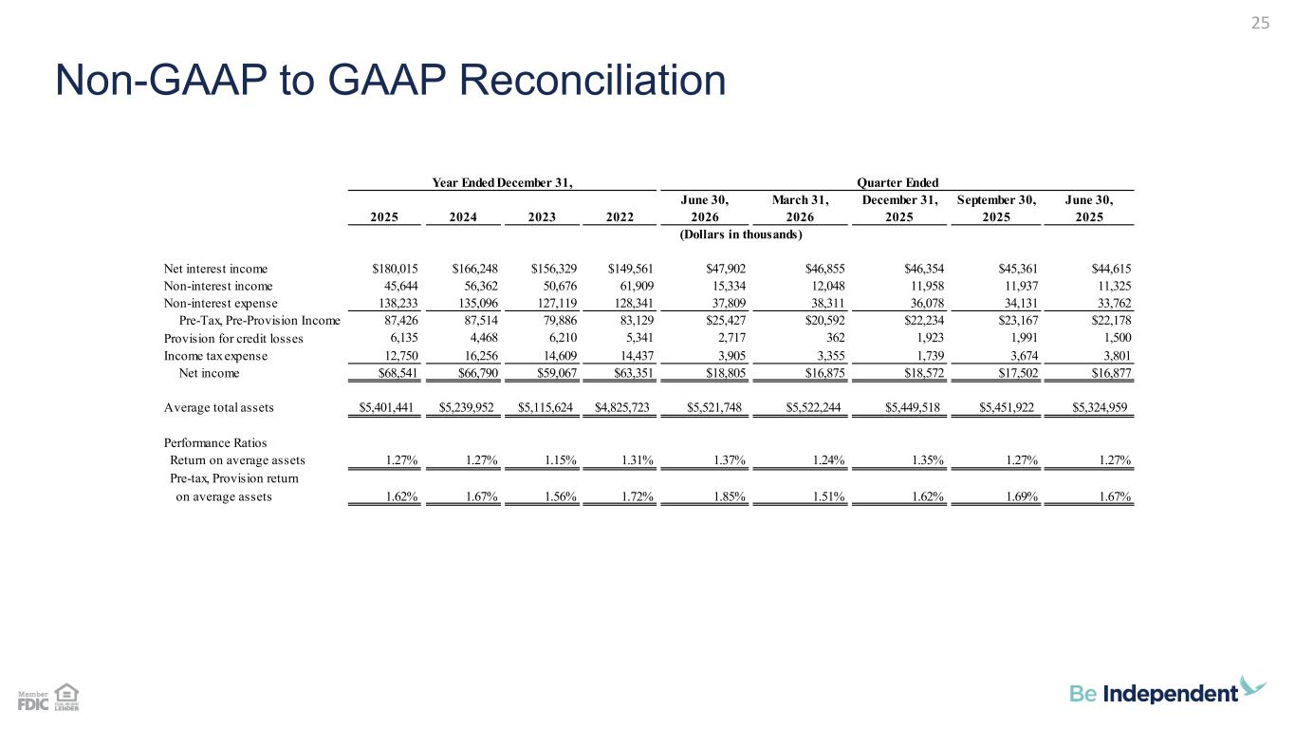
Non-GAAP to GAAP Reconciliation 25 June 30, March 31, December 31, September 30, June 30, 2025 2024 2023 2022 2026 2026 2025 2025 2025 Net interest income $180,015 $166,248 $156,329 $149,561 $47,902 $46,855 $46,354 $45,361 $44,615 Non-interest income 45,644 56,362 50,676 61,909 15,334 12,048 11,958 11,937 11,325 Non-interest expense 138,233 135,096 127,119 128,341 37,809 38,311 36,078 34,131 33,762 Pre-Tax, Pre-Provision Income 87,426 87,514 79,886 83,129 $25,427 $20,592 $22,234 $23,167 $22,178 Provision for credit losses 6,135 4,468 6,210 5,341 2,717 362 1,923 1,991 1,500 Income tax expense 12,750 16,256 14,609 14,437 3,905 3,355 1,739 3,674 3,801 Net income $68,541 $66,790 $59,067 $63,351 $18,805 $16,875 $18,572 $17,502 $16,877 Average total assets $5,401,441 $5,239,952 $5,115,624 $4,825,723 $5,521,748 $5,522,244 $5,449,518 $5,451,922 $5,324,959 Performance Ratios Return on average assets 1.27% 1.27% 1.15% 1.31% 1.37% 1.24% 1.35% 1.27% 1.27% Pre-tax, Provision return on average assets 1.62% 1.67% 1.56% 1.72% 1.85% 1.51% 1.62% 1.69% 1.67% Year Ended December 31, (Dollars in thousands) Quarter Ended

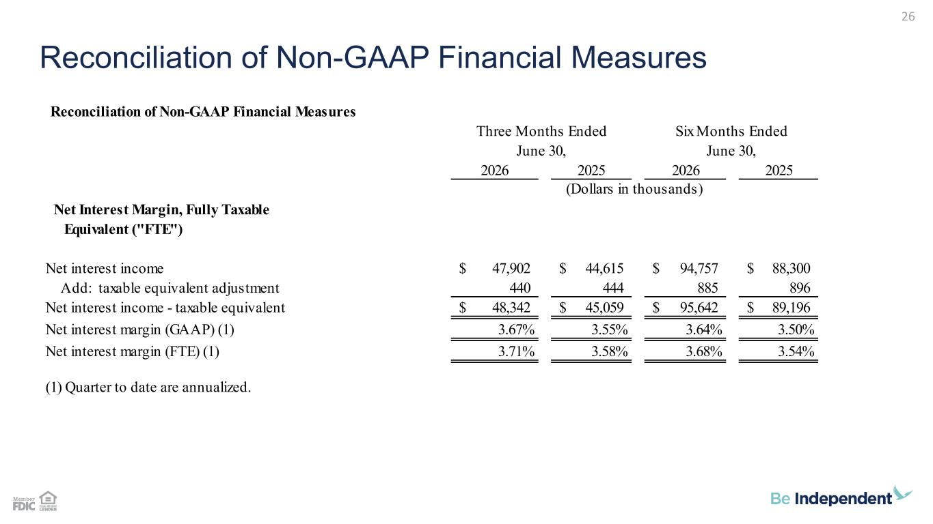
Reconciliation of Non-GAAP Financial Measures 26 Reconciliation of Non-GAAP Financial Measures 2026 2025 2026 2025 Net Interest Margin, Fully Taxable Equivalent ("FTE") Net interest income 47,902$ 44,615$ 94,757$ 88,300$ Add: taxable equivalent adjustment 440 444 885 896 Net interest income - taxable equivalent 48,342$ 45,059$ 95,642$ 89,196$ Net interest margin (GAAP) (1) 3.67% 3.55% 3.64% 3.50% Net interest margin (FTE) (1) 3.71% 3.58% 3.68% 3.54% (1) Quarter to date are annualized. Three Months Ended Six Months Ended June 30, June 30, (Dollars in thousands)

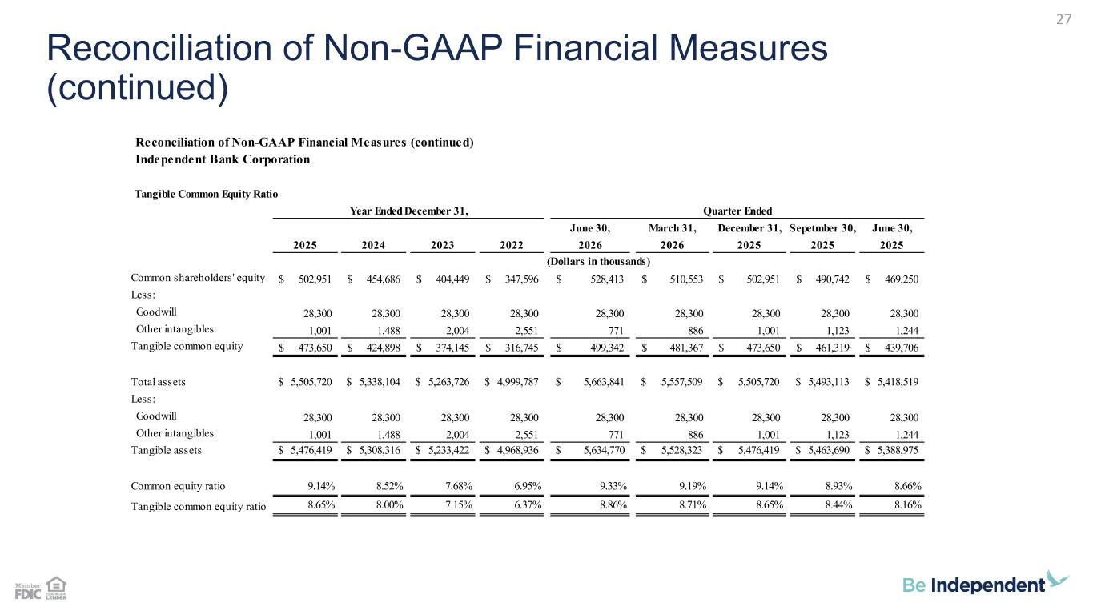
Reconciliation of Non-GAAP Financial Measures (continued) 27 Reconciliation of Non-GAAP Financial Measures (continued) Independent Bank Corporation Tangible Common Equity Ratio June 30, March 31, December 31, Sepetmber 30, June 30, 2025 2024 2023 2022 2026 2026 2025 2025 2025 Common shareholders' equity 502,951$ 454,686$ 404,449$ 347,596$ 528,413$ 510,553$ 502,951$ 490,742$ 469,250$ Less: Goodwill 28,300 28,300 28,300 28,300 28,300 28,300 28,300 28,300 28,300 Other intangibles 1,001 1,488 2,004 2,551 771 886 1,001 1,123 1,244 Tangible common equity 473,650$ 424,898$ 374,145$ 316,745$ 499,342$ 481,367$ 473,650$ 461,319$ 439,706$ Total assets $ 5,505,720 $ 5,338,104 $ 5,263,726 $ 4,999,787 $ 5,663,841 $ 5,557,509 $ 5,505,720 $ 5,493,113 $ 5,418,519 Less: Goodwill 28,300 28,300 28,300 28,300 28,300 28,300 28,300 28,300 28,300 Other intangibles 1,001 1,488 2,004 2,551 771 886 1,001 1,123 1,244 Tangible assets $ 5,476,419 $ 5,308,316 $ 5,233,422 $ 4,968,936 $ 5,634,770 $ 5,528,323 $ 5,476,419 $ 5,463,690 $ 5,388,975 Common equity ratio 9.14% 8.52% 7.68% 6.95% 9.33% 9.19% 9.14% 8.93% 8.66% Tangible common equity ratio 8.65% 8.00% 7.15% 6.37% 8.86% 8.71% 8.65% 8.44% 8.16% Year Ended December 31, (Dollars in thousands) Quarter Ended

